**SAP: SYSTEMS APPLICATIONS AND PRODUCTS**

**ARCHITECTURE OF SAP:**

Two type of SAP Architecture

R/2 Architecture: Server layer and database layer.

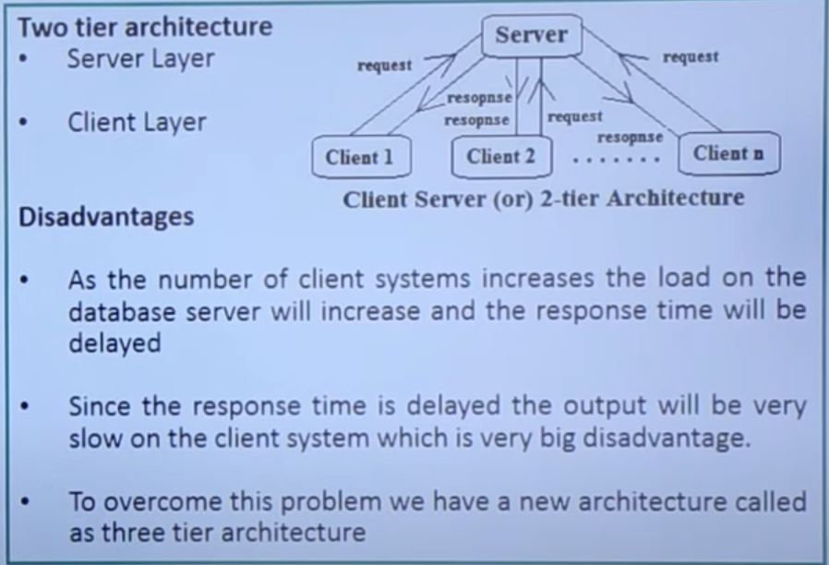

1. R/3 Architecture :

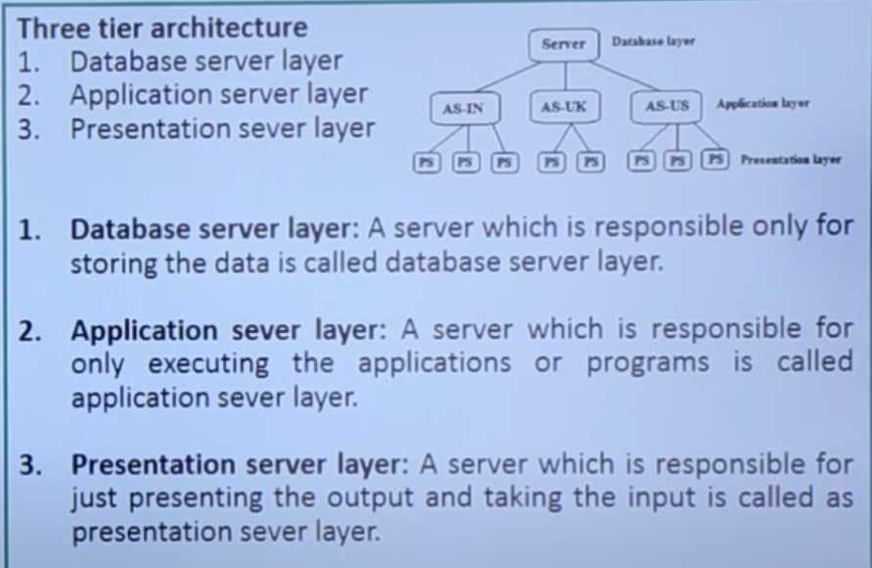

**ABAP: ADVANCED BUSINESS APPLICATION PROGRAMMING**

It was initially used for report creation, later fully evolved as a programming language.

**SAP MODULES:**

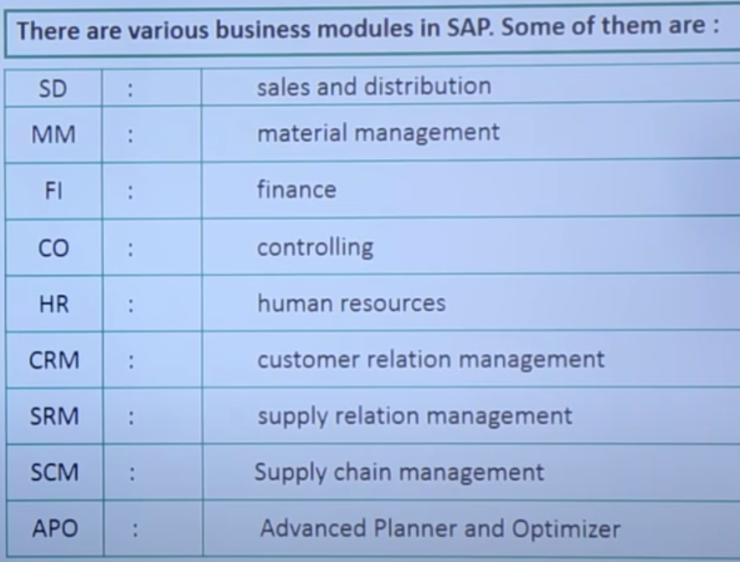

**TRANSACTON CODE:**

It is a unique code or shortcut code which is used to display a specific screen.

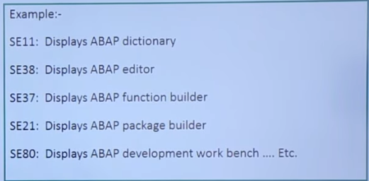

**TRANSPORT REQUEST :(TR)**

**Creating a TR from Dev to Quality**

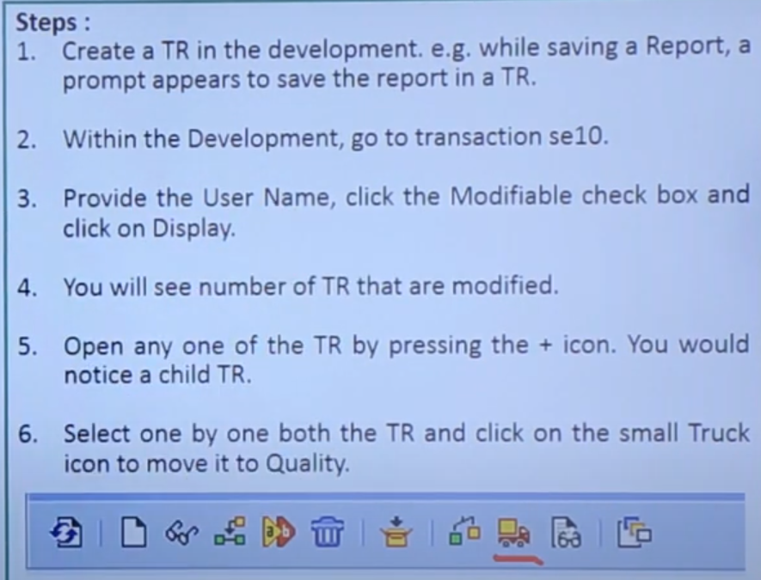

**Moving a TR from Dev to quality**

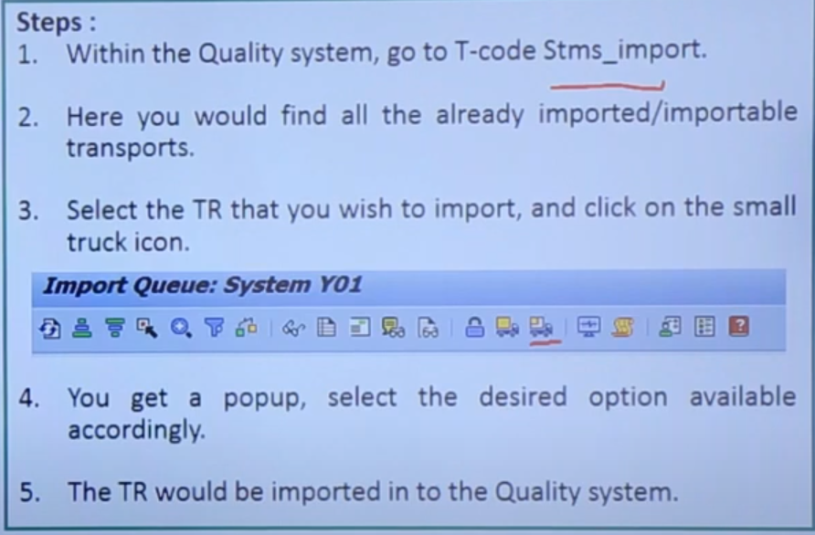

**PACKAGE BUILDER:**

Package builder is a type of development object that acts as a container to store development objects such as function modules, screens, menus and transactions.

* It is created using SE21 T- code or SPACKAGE.
* Name package starting with Z or Y.

ex: Z_Cust_package.

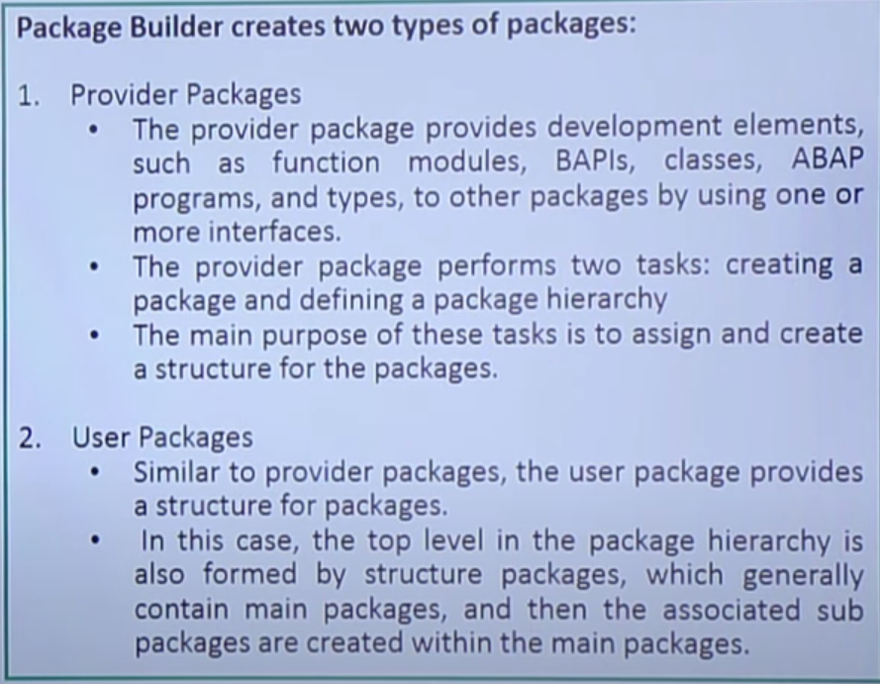

**Developing a ABAP Program:**

* Go to SE38 T-code, provide name and click on Create.
* Provide some description or Title.
* A TR will be generated and the ABAP editor will get opened.

**WRITE STATEMENT:**

It is used to print the text on the output screen.

Ex program:

* Report ZSample.

Data name1 (4) Type C.

name1 = ‘abcd’.

Write name1.

**DATA DICTIONARY:**

ABAP Data dictionary is the central repository where we define and maintain the objects which are related to database.

Two ways to open data dictionary:

1. SAP Menu >> Tools >> ABAP Workbench >> Development >> ABAP Dictionary or
2. Simply enter the Transaction code ‘SE11’.

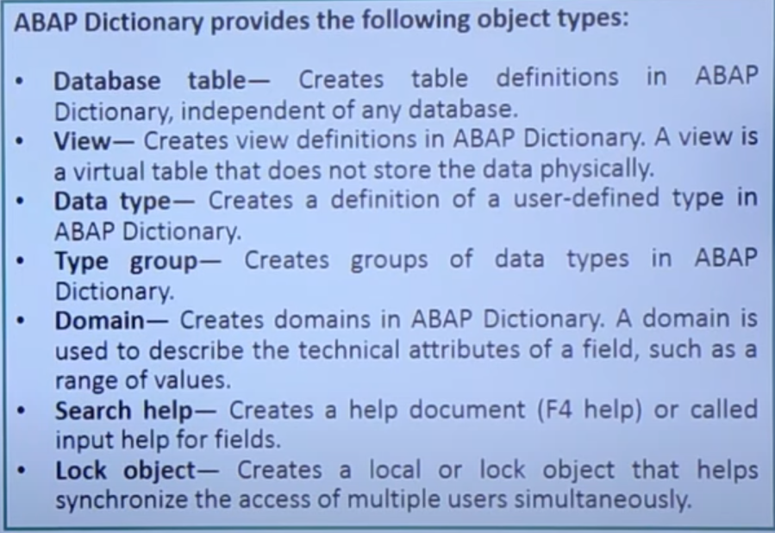

* **DATABASE TABLE:**

It is a combination of rows and columns, where rows are records and columns are known by fields.

**FIELD:**

It is a combination of Domain and Data element

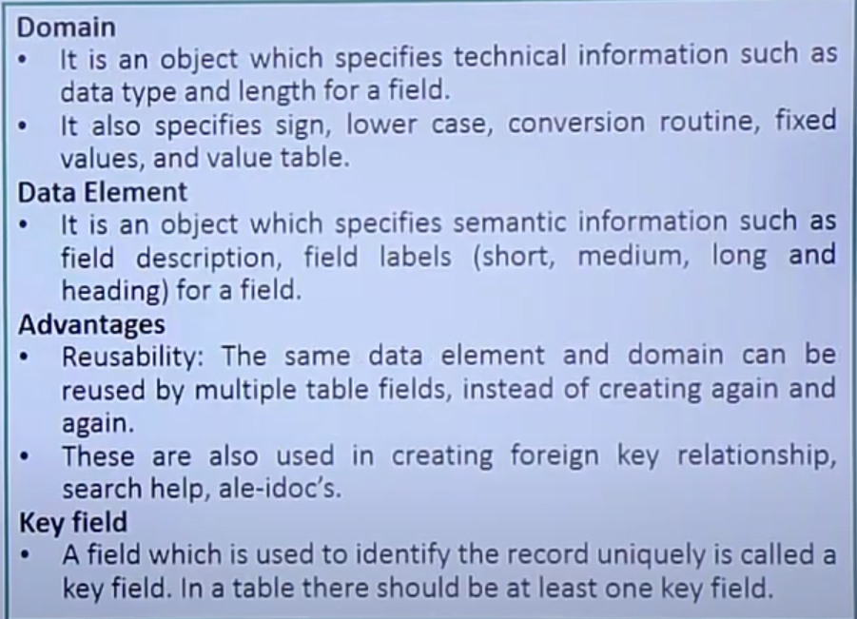

**STEPS TO CREATE A TABLE:**

* Go to **SE11** T-code, provide table name ‘Z_customTable’ and click on create.
* Provide description and specify delivery class as ‘A’.
* Specify display maintenance allowed and click on fields tab.
* Provide field name and data element name, then click on Save
* Click on technical settings button
* Provide the details as data class 🡪 APPL0, Size category 🡪 0
* Click Save and click on back, then save and activate the table.

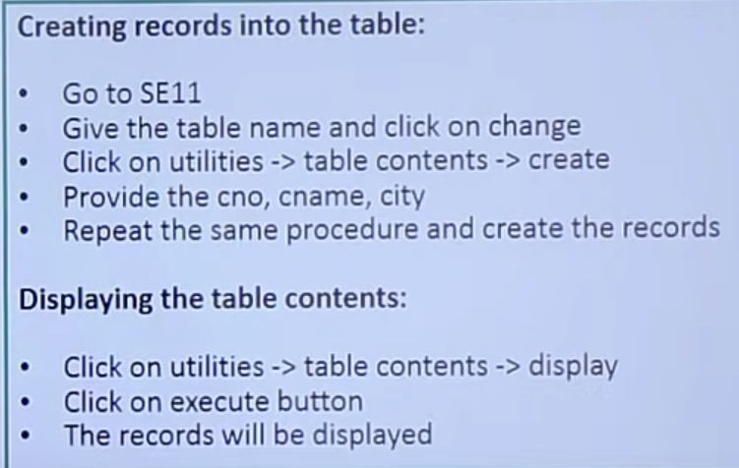

**COMPONENTS OF TABLE:**

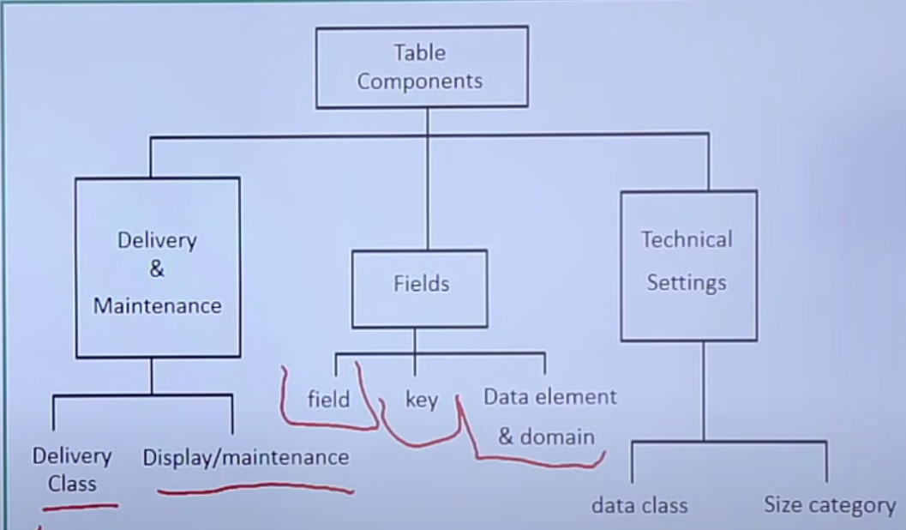

**DELIVERY CLASS:**

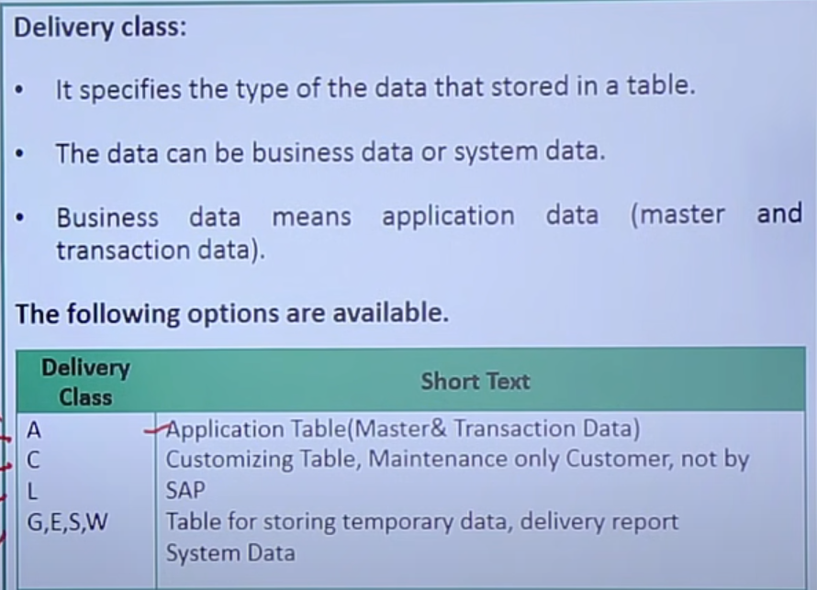

**DISPLAY MAINTENANCE:**

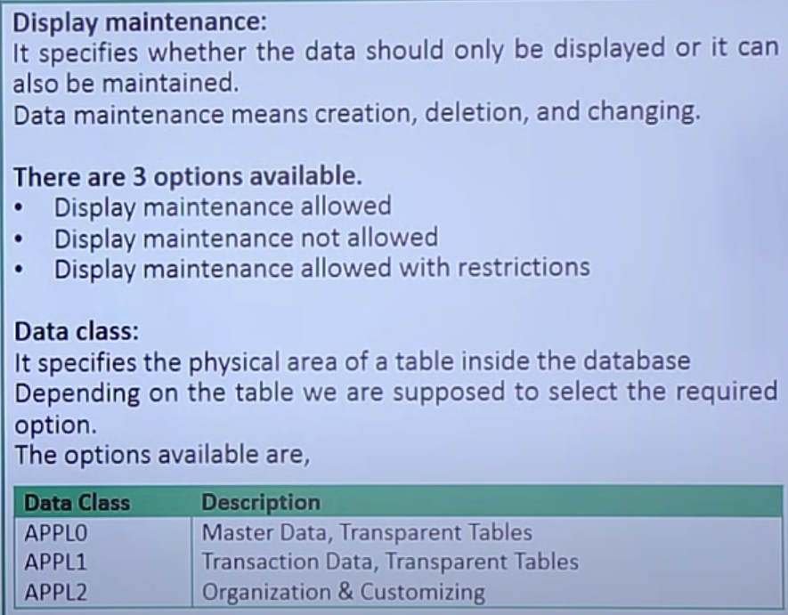

**STRUCTURES IN ABAP:**

* It is a Data Type in DDIC, composed of data element, table type and tables.
* Structures are similar to tables, except it doesn’t have Primary key or technical characteristics.
* These are reusable components, it is used to define the same work area in multiple programs.
* A Structure can be nested within another structure.

**Two options for including structures in tables:**

* Include Structure
* Append Structure

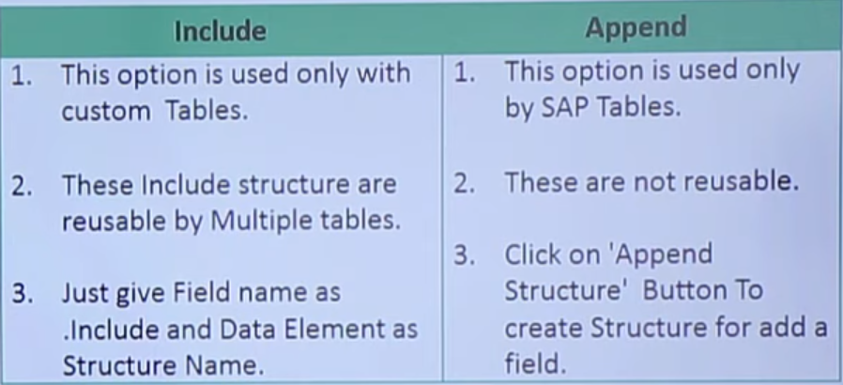

**STEPS TO CREATE INCLUDE STRUCTURES:**

**Step-1:**

* Go to SE11 T-code, Select Data Type and provide a name, Then click on Create.
* Select ‘Structure’ and provide description
* Specify the fields and data elements, then Save and activate

**Step -2:**

* Open any table which is already created.
* Provide the field name as ‘.include’, data element as structure name which is create above.
* Then Enter, the fields will be automatically copied.

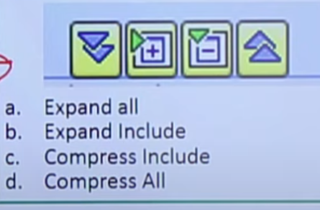

**EXAMPLE ON APPEND STRUCTURE:**

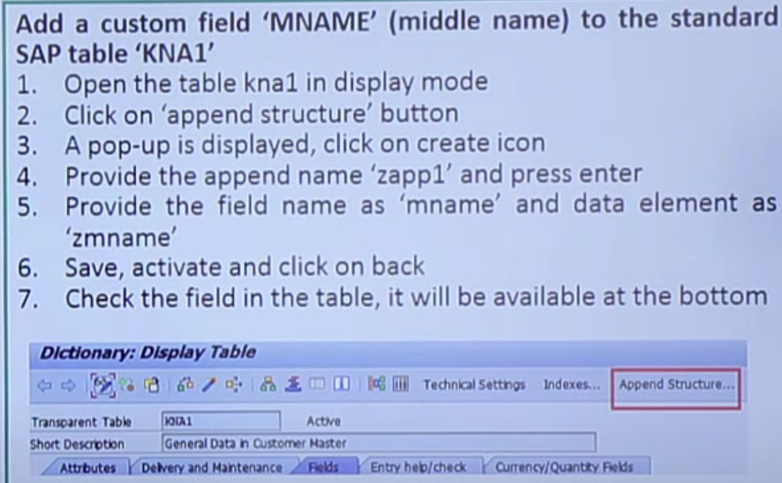

**CURRENCY AND QUANTITY FIELDS:**

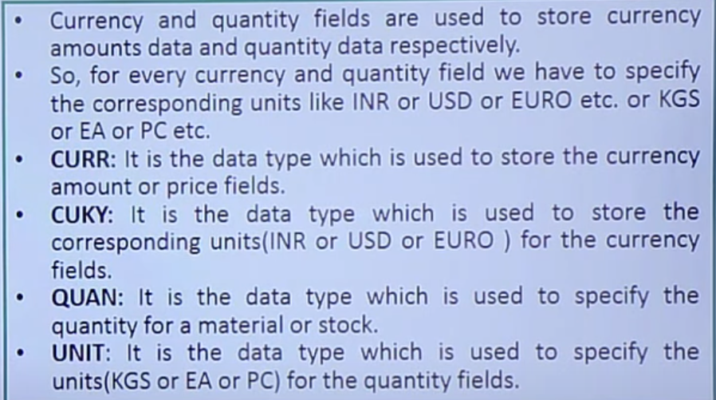

Example:

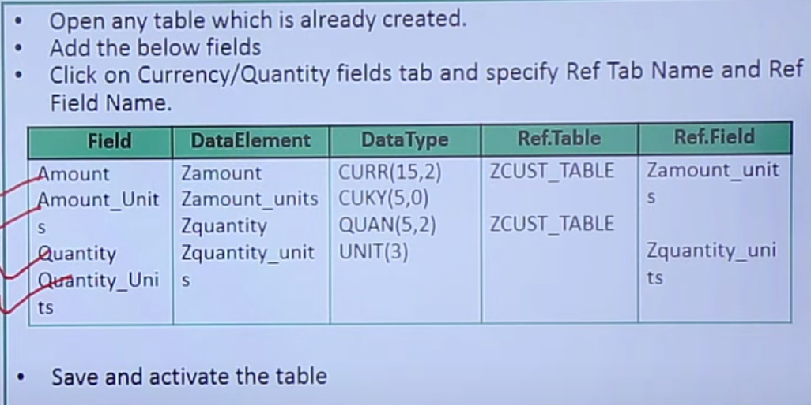

**FOREIGN KEYS;**

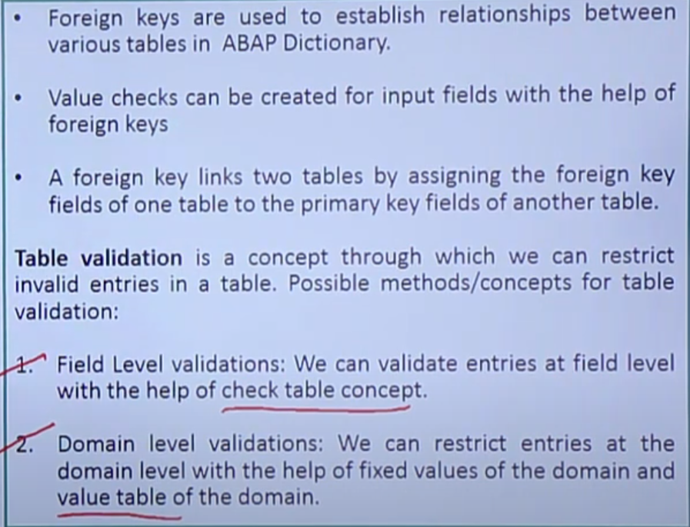

**CHECK TABLE:**

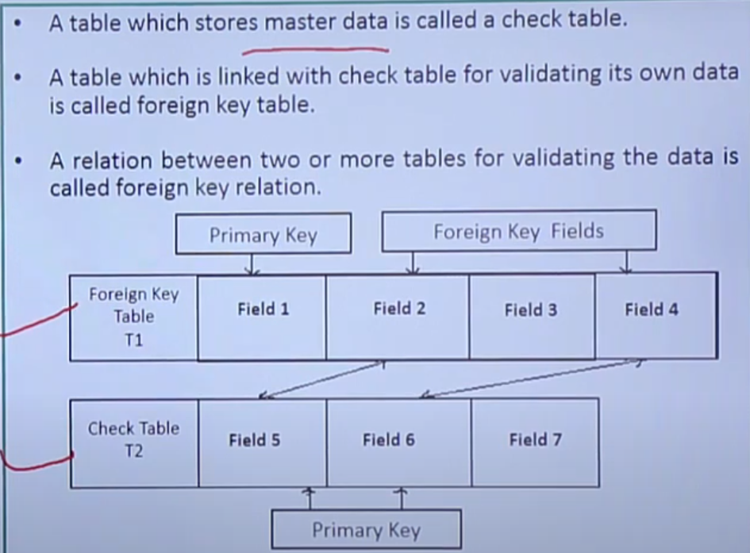

* **STEPS TO CREATE FOREIGN KEY RELATION:**

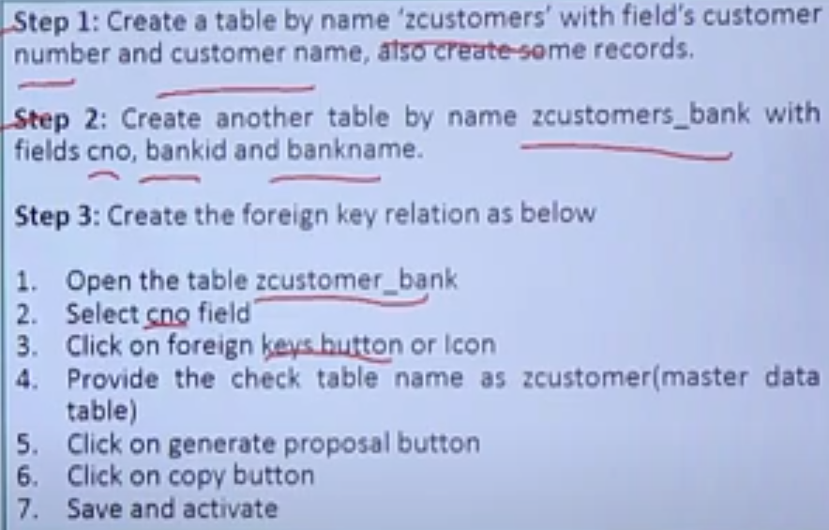

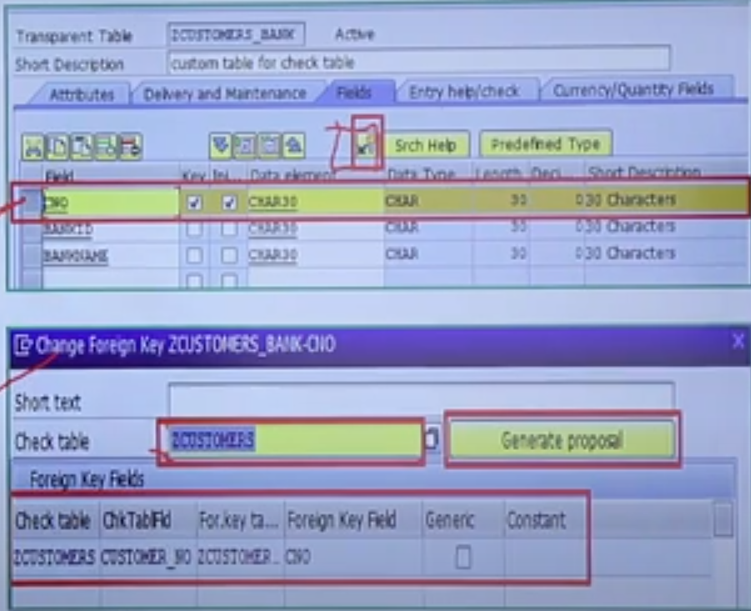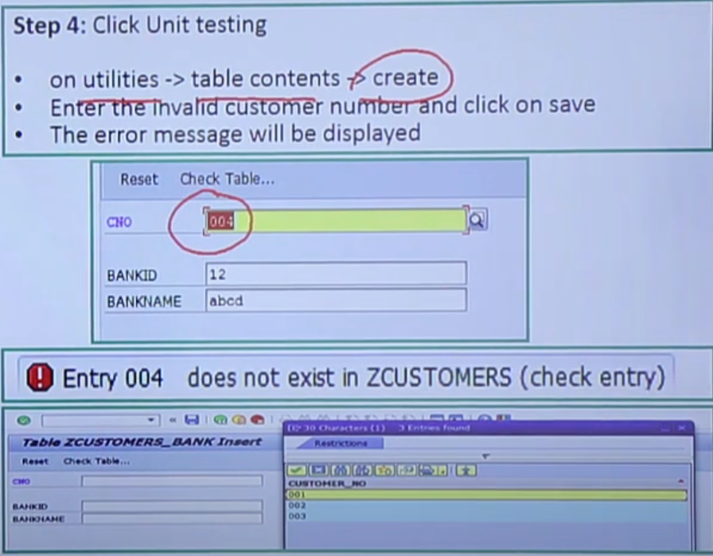

**VALUE TABLE:**

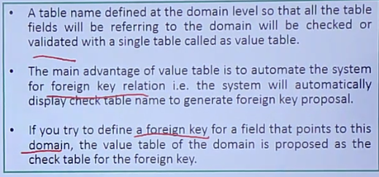

**STEPS TO CREATE VALUE TABLE:**

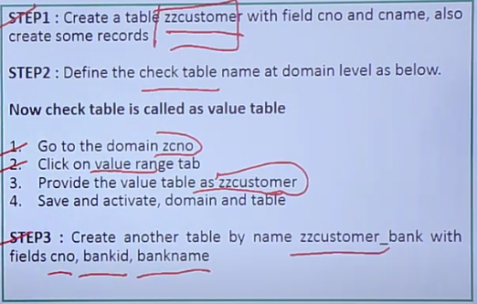

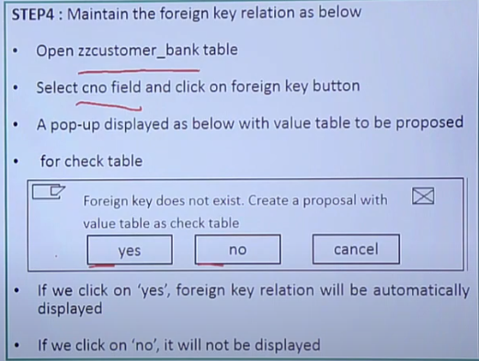

**Difference between check table and value table:**

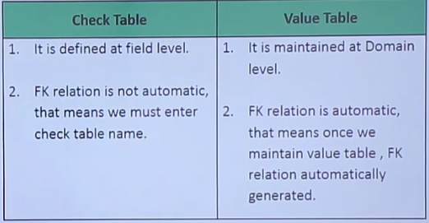

**TABLE MAINTENANCE GENERATOR:**

* It is a standard SAP program created in the form of function modules to maintain mass or bulk amount of data instead of maintaining each and every record.
* Maintenance means creation, deletion and modification.
* It is also used for validating the table data using the concept of events.

**STEPS FOR TABLE MAINTENANCE GENERATOR:**

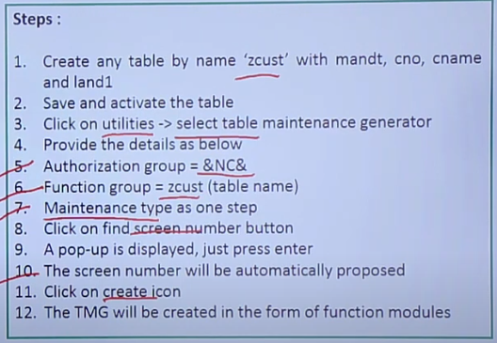

**ACTIVATING TMG AND UNIT TESTING:**

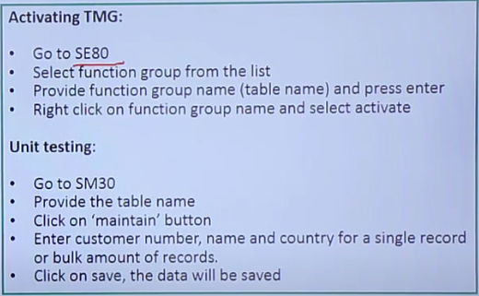

**VIEWS IN DDIC:**

* A view is a collection of fields from multiple tables, It doesn’t store any data.
* Whenever a view is executed, it displays the data by selecting from multiple tables.
* To create a view, we must join tables.
* To join the tables , there must be at least one common key field.

**JOINS:**

* It is a concept to link two or multiple tables for displaying the data.

There are two joins

* Inner join
* Outer join

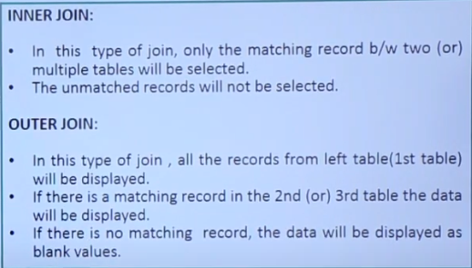

**TYPES OF VIEWS:**

There are four types of views

1. **Database view:**

* A view created on two or more tables by clubbing the fields using inner join.
* In this view, we can only read the data and can not do any maintenance operation.
* Database uses only inner join, so that it selects only the matching records b/w tables.

**Steps to create Database view**

* Go to SE11 and select the view and name it.
* Click on create and select Database view and click copy button.
* Click on Tables/Joins tab and provide table names and Join conditions shown in picture below

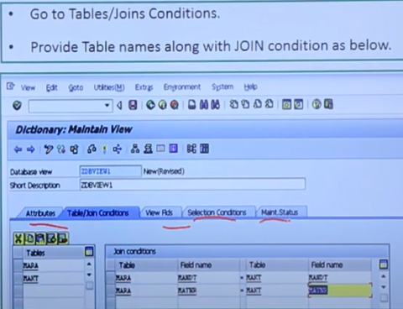

* Now click on view Fields tab and then click on Table fields button.
* Double click on 1st table and select fields and then click on copy button
* Similarly double click on 2nd table and select the fields.
* Now go to selection condition tab, provide the condition.
* Save, check and activate.
* Now click on content icon and then click on Execute button.

1. **Projection view:**

* A view is created on single table is called “Projection View”.
* Main advantage of using this project view is, we can project only required or limited fields by filtering the unwanted fields.
* We can read and maintain the data, since the view is created on single table.
* From database point of view, projection views improve the system performance.

**Steps to create projection view**

* Go to SE11 and select view and name it.
* Click on create and select the **projection view** and click on copy button.
* Provide short description and give table names.
* Click on table fields button and select the fields.
* Click on Maintenance status tab.
* Select ‘Read and change’ , then save , check and Activate.
* Click on contents icon, click on execute and the data will be displayed.

1. **Help view:**

* A view created on two or more tables for ‘search-helps’ is called Help view.
* It uses outer join concept
* Here we can read the data, but cant maintain the data.
* we can not execute help views directly, because they are designed specially for ‘search-helps’.

**Steps to create help view:**

* Go to SE11 and select view and name it and click on create button.
* Select the Help view and click on copy button.
* Provide short description and give the table and press enter
* Now click on relationship button, select and click on copy button.
* Join condition automatically proposed by system.
* Go to view fields tab.
* Now click on table field’s button and select table1 and click on choose button and select the fields and click on copy button.
* Similarly, select table2 and select required fields.
* Go to selection conditions tab and give the condition.
* Click on save, check and activate.

1. **Maintenance view:**

* A view created on two or more tables using inner join is called Maintenance view.
* In this view, we can read and maintain the data.
* Maintenance view should not be created on standard tables. Because the data inconsistency problem will occur when we change the records.
* It can be created on custom tables (Z/Y tables).

**Steps to create Maintenance view:**

* Go to SE11 and select view and name it and click on create button.
* Select the Maintenance view and click on copy button.
* Provide short description and give the table and press enter
* Now click on relationship button, select and click on copy button.
* Join condition automatically proposed by system.
* Go to view fields tab.
* Now click on table field’s button and select table1 and click on choose button and select the fields and click on copy button.
* Similarly, select table2 and select required fields.
* Go to selection conditions tab and give the condition.
* Go to maintenance status tab, select **Read, change, delete and insert** button.
* Click on save, check and activate.
* Click on **Utilities**, 🡪**Table Maintenance generator**.

Provide details of Authorization group, function group and Maintenance type as ‘one step’ and Overview screen as ‘1’.

* Click on create button and then click on Save.
* Go to SM30
* Provide the view name and click on maintain button.

**DATA ELEMENTS:**

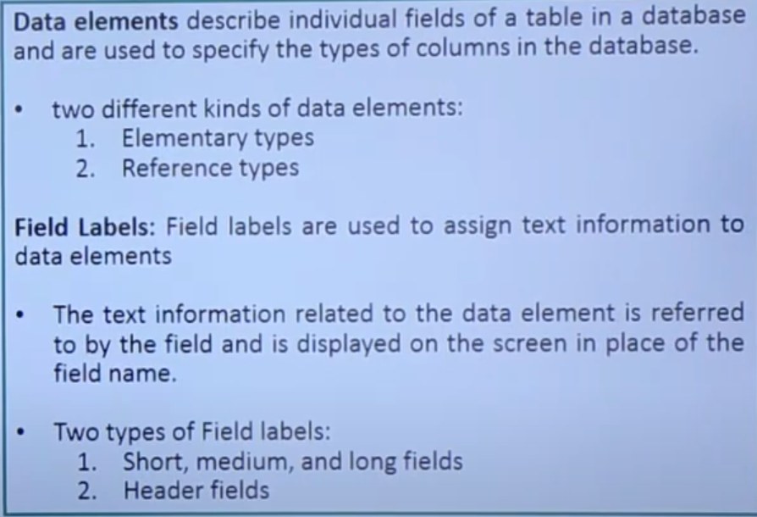

**STEPS TO CREATE DATA ELEMENTS:**

* Go to SE11 and select data type and name it
* Click on create and select data element
* Provide short description and select the type of data element.
* If Elementary type, then either provide a domain name or predefined type.
* Click on fields label tab, specify short, medium, long and heading labels.
* Save and activate it.
* Then we can use those data elements.

**TYPE GROUP:**

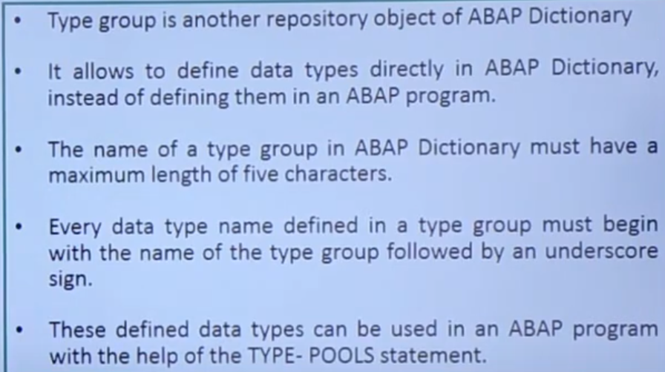

**STEPS TO CREATE A TYPE GROUP:**

* Go to SE11 and select **Type Group.**
* Enter the type group name and click on create.
* Then, enter the following code snippet in the maintenance screen of the ZTYPE type group

TYPE – POOL ZTYPE

TYPES: ZTYPE_NAME (30) TYPE C,

ZTYPE_AGE (3) TYPE I.

* In this code snippet, two data types are created. The declared type group i.e; ZTYPE, Can be used in an ABAP program.

Ex:

REPORT ZTEST

TYPE-POOLS ZTYPE

DATA: NAME TYPE ZTYPE_NAME,

AGE TYPE ZTYPE_AGE.

**DOMAINS:**

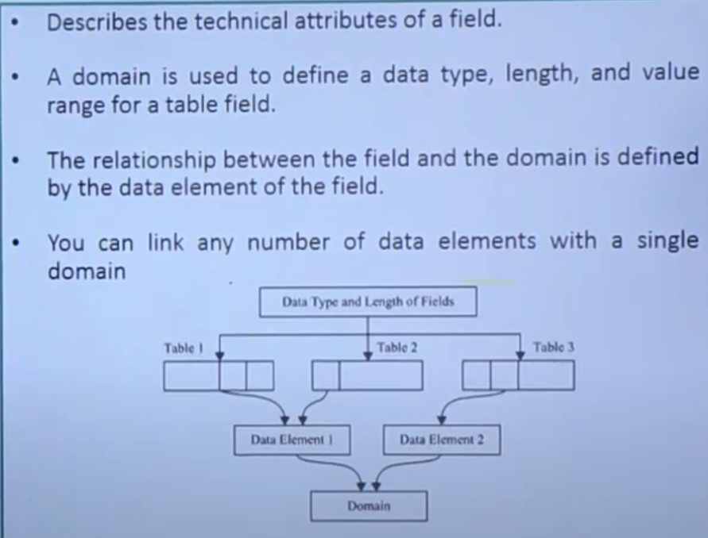

**Steps to create a domain:**

* Go to SE11
* Select domain and give it a name, then click on create
* Provide short description
* Provide data type as CHAR and length as 10
* Press enter, save, check and activate.

**SEARCH HELPS:**

* Search helps is an another repository object of ABAP Dictionary.
* They are used to display all the possible values for a field in the form of a list.
* It provides input helps F4 for different fields.
* You can select the values which are to be entered in the fields from the list.

**TYPES OF SEARCH HELPS:**

1. ELEMENTARY SEARCH HELP
2. COLLECTIVE SEARCH HELP
3. APPEND SEARCH HELP

**STEPS TO CREATE SEARCH HELP:**

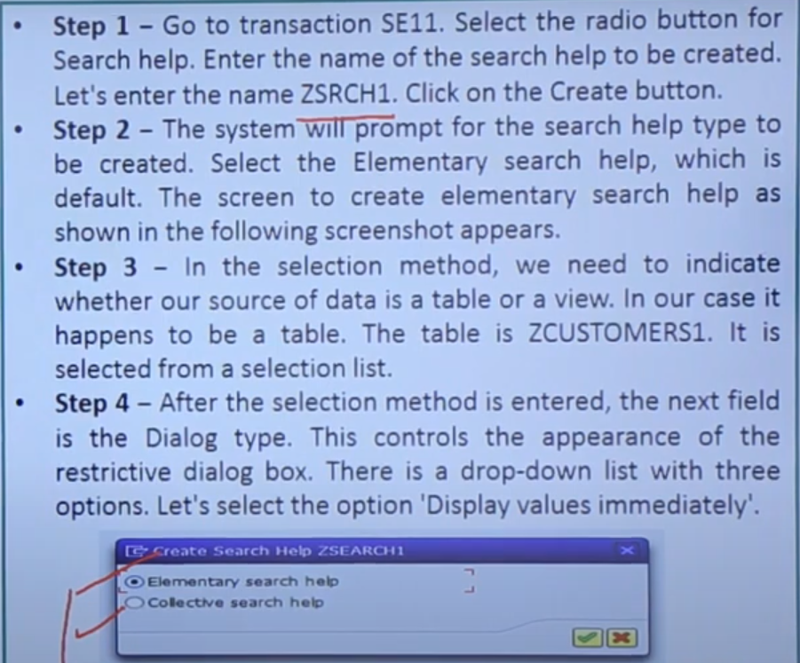

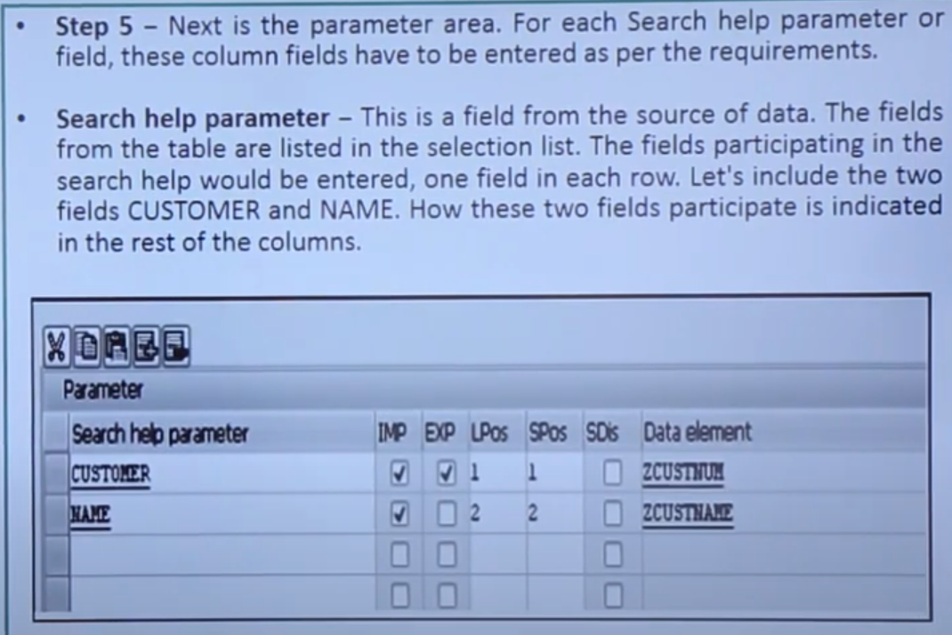

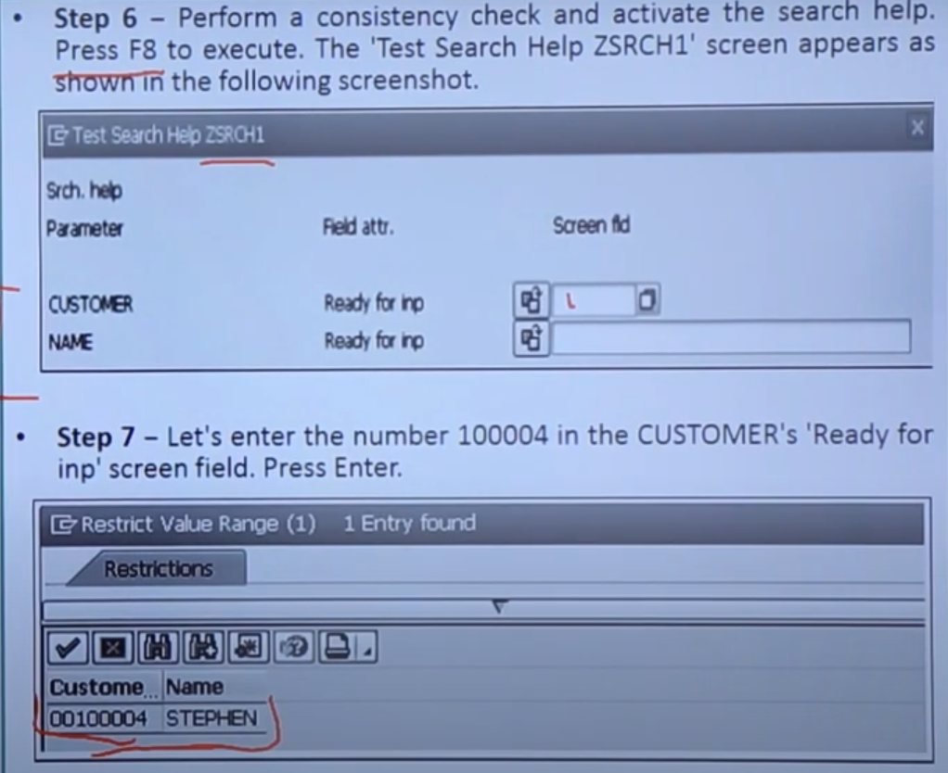

**LOCK OBJECTS:**

* Lock objects is a feature offered by ABAP dictionary.
* It is used to synchronize access to the same data by more than one program
* Lock objects are used in SAP to avoid the inconsistency when data is inserted into or changed in the database.
* Tables whose data records are to be locked must be defined in a lock object, along with their key fields.

**STEPS TO CREATE A LOCK OBJECT:**

* Go to SE11 and click on LOCK OBJECT
* Name object starting with ‘E’ and click on create button.
* Enter short description and click on tables tab.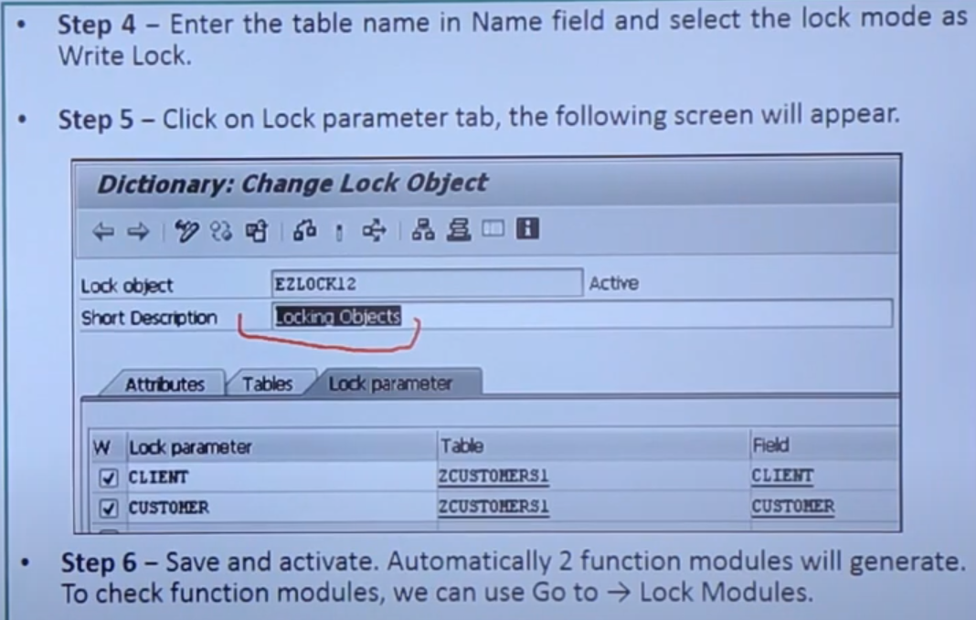

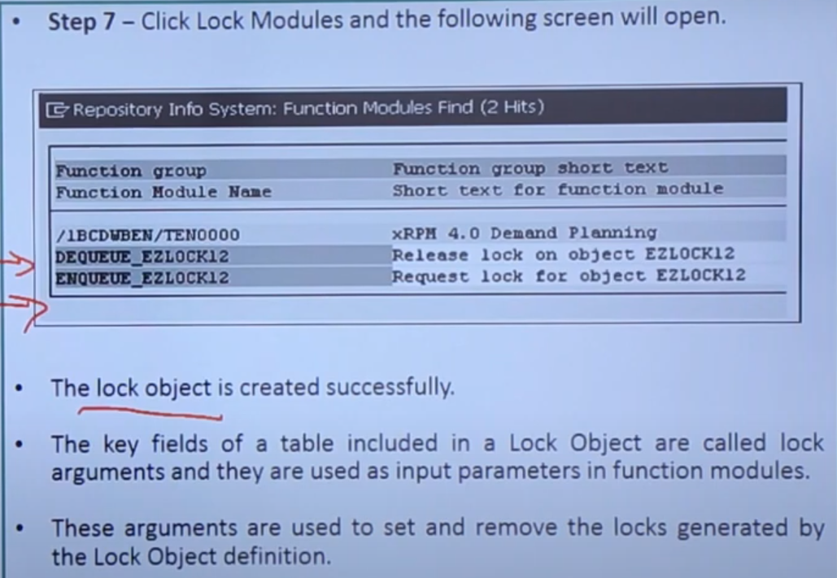

**INTERNAL TABLES AND WORKAREA:**

**INTERNAL TABLE:**

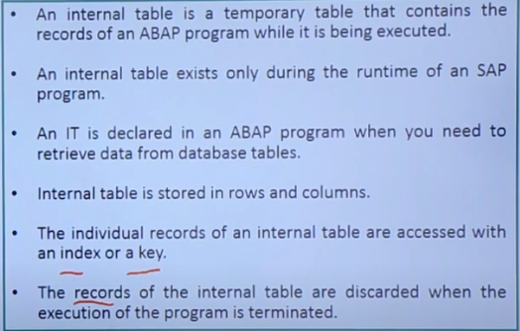

**SYNTAX FOR INTERNAL TABLE:**

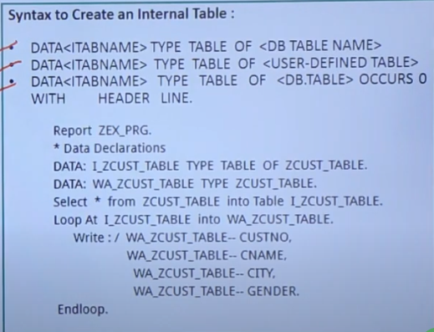

**EXAMPLE OF USING INTERNAL TABLE:**

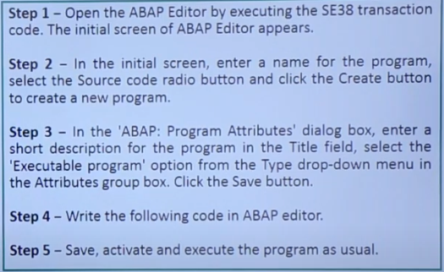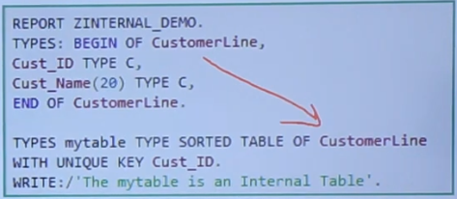

**WORKAREA:**

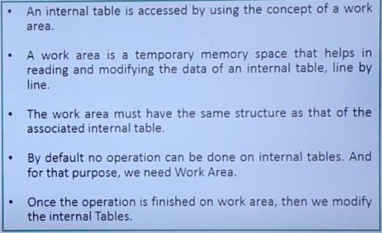

**OPERATIONS ON INTERNAL TABLE:**

There are multiple operation that can be performed on internal tables

1. **APPEND:**

It is used to add a single record from WORKAREA to INTERNAL TABLE.

This record is always added at the bottom.

SYNTAX:

APPEND <WA> TO <ITAB>.

1. **INSERT:**

It is used to insert a record from WORKAREA to INTERNAL TABLE at a specified location.

SYNTAX:

INSERT <WA> INTO <ITAB> INDEX <INDEX NO>.

1. **SORT:**

It is used to sort the data of internal table in ascending or descending order.

By default it is ascending order.

SYNTAX:

SORT <ITAB> BY F1 F2 F3 …. <ASCENDING/DESCENDING>

1. **DESCRIBE TABLE:**

It is used to find the total no of records in an internal table.

SYNTAX:

DESCRIBE TABLE <ITAB1> LINES <VARIABLE>

1. **READ TABLE WITH INDEX:**

It is used to read a single record from ITAB into WA specified by index no.

SYNTAX:

READ TABLE <ITAB> INTO <WA> INDEX <INDEX NO>

1. **MODIFY:**

It is used to modify single or multiple records based on condition.

SYNTAX:

MODIFY <ITAB> FROM <WA> TRANSPORTING F1 F2 F3 …..

Where F1 = value and F2 = value

1. **DELETE:**

This statement is used to delete single or multiple records based on condition.

SYNTAX:

DELETE <ITAB> INDEX <INDEX NO>

1. **DELETE ADJACENT DUPLICATES:**

This statement is used to delete adjacent records from the ITAB.

SYNTAX:

DELETE ADJACENT DUPLICATES FROM <ITAB>

COMPARING F1 F2 F3 ALL FIELDS.

1. **CLEAR:**

This statement is used to delete the data from WA

SYNTAX:

CLEAR <WA>

1. **REFRESH:**

This statement is used to delete the data from ITAB.

SYNTAX:

REFRESH <ITAB>

1. **FREE:**

This statement is used to delete the data from WA and ITAB

SYNTAX:

FREE <WA/ITAB>

1. **APPEND LINES OF:**

This statement is used to append to data from ITAB into another ITAB based on selection.

The data will append at bottom in the 2nd ITAB

SYNTAX:

APPEND LINES OF <ITAB1> FROM <INDEX NO1> TO <INDEX NO2> INTO <ITAB2>.

1. **INSERT LINES OF:**

This statement is used to insert the data from one ITAB into another ITAB at specified location based on selection.

SYNTAX:

INSERTLINES OF <ITAB> FROM <INDEX NO1> TO <INDEX NO2> INTO <ITAB2> INDEX <INDEX NO>

1. **MOVE ITAB1[] TO ITAB2[]:**

This statement is used to move the entire data from one ITAB1 to ITAB2

SYNTAX:

ITAB1[] = ITAB2[]

1. **COLLECT:**

This statement checks whether the WA record already exists with the

SYNTAX:

COLLECT <WA> INTO <ITAB>

Checks whether the WA already exists with same key

If yes, ADD NUMERICAL FIELDS

If no, APPEND a new record

**TYPES OF INTERNAL TABLES:**

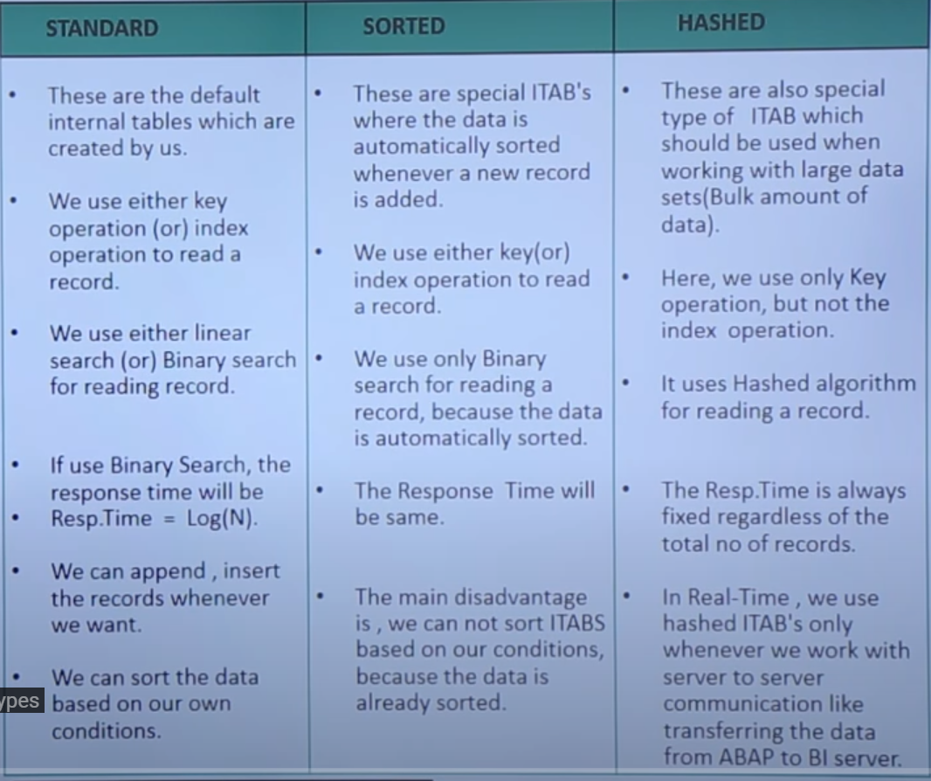

**DATABASE:**

SAP R/3 is independent of database being used. i. e; SAP can use any database to store the data.

We use databases to store mass amount of data

Whenever we want to store the data into database, we need to use the respective database language statements.

**R/3 INTERFACE LAYER:**

It is an interface which is given by standard SAP software which is used to convert the ABAP language statements into respective database statements and vice versa.

There are two types of statements:

1. OPEN SQL Statements

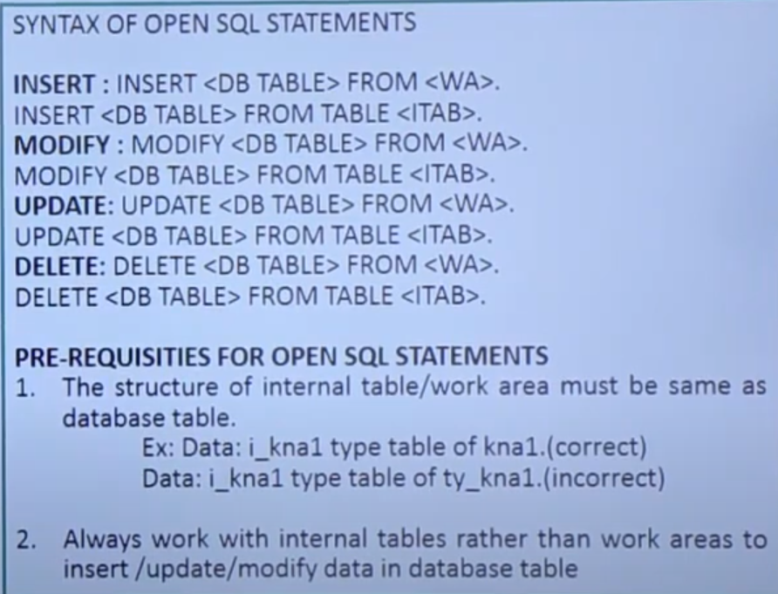

1. NATIVE SQL Statements

**SELECT STATEMENT:**

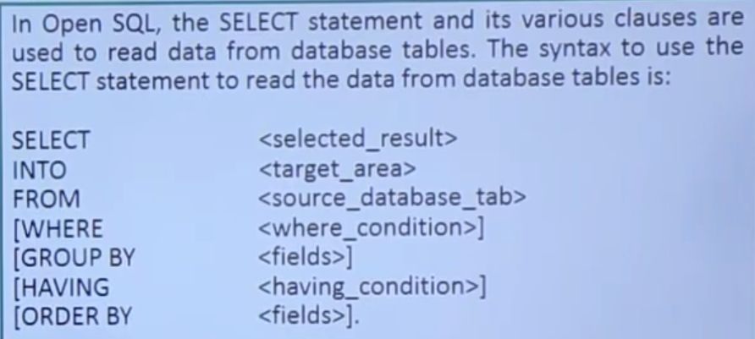

**SYSTEM VARIABLES:**

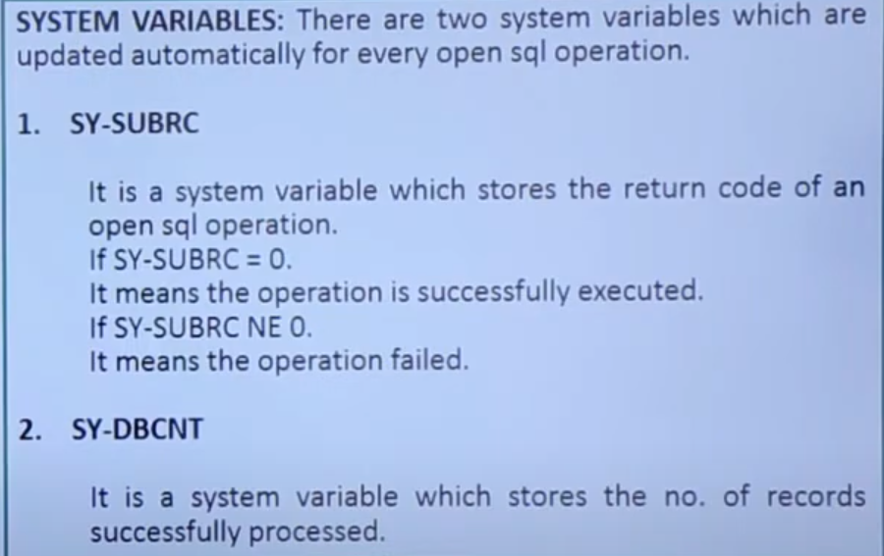

**EXAMPLE:**

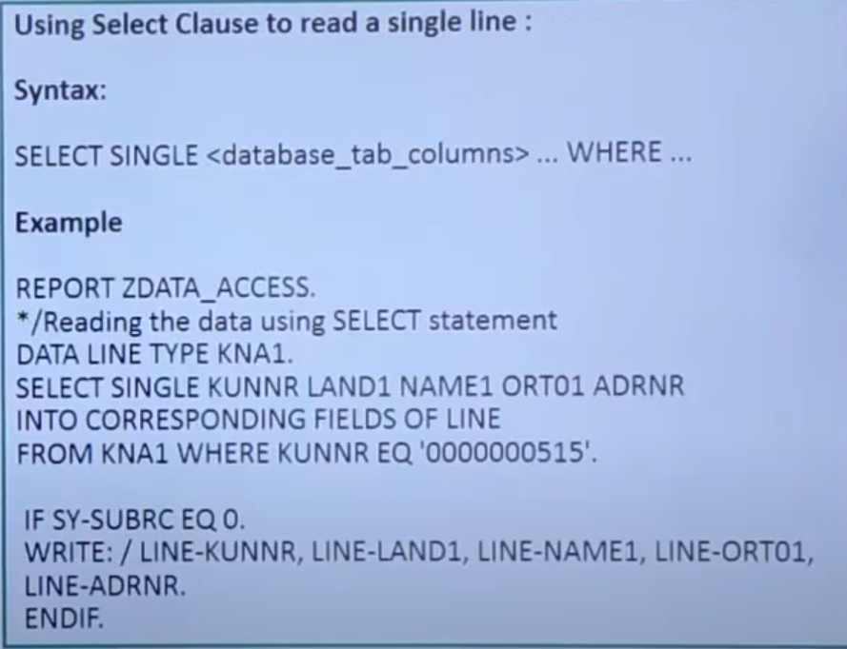

**SELECT WITH JOINS:**

This statement is used to fetch the data simultaneously from multiple tables.

That means the multiple tables must be joined using one or two fields.

There should be atleast one common field between tables.

There are two types of joins:

1. **Inner join:**

In this join, only matching records between the tables will be fetched.

The unmatched records are not selected.

1. **Outer join:**

In this join, all the records from the left table or first table are selected first.

If any matching records from the second or third tables, then data will be displayed.

If there are no matching records, the data will be displayed as blank from second & third tables.

**SELECT WITH ALL ENTRIES:**

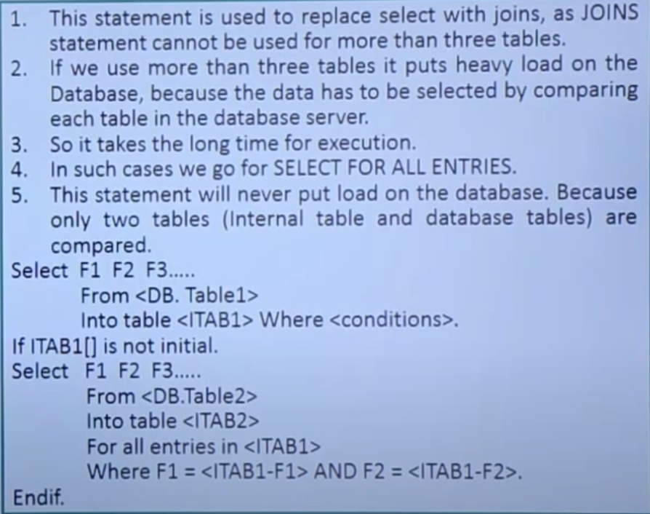

**SELECTION SCREENS:**

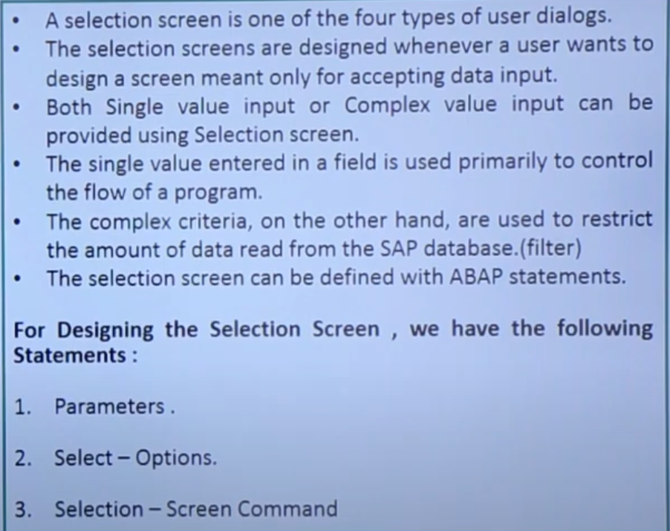

1. **PARAMETERS:**

The parameters statement is used to define a single field on the selection screen.

The variables defined using the parameters statement accepts only single values.

Parameters are used to create input fields, checkboxes, and radio buttons on the selection screen.

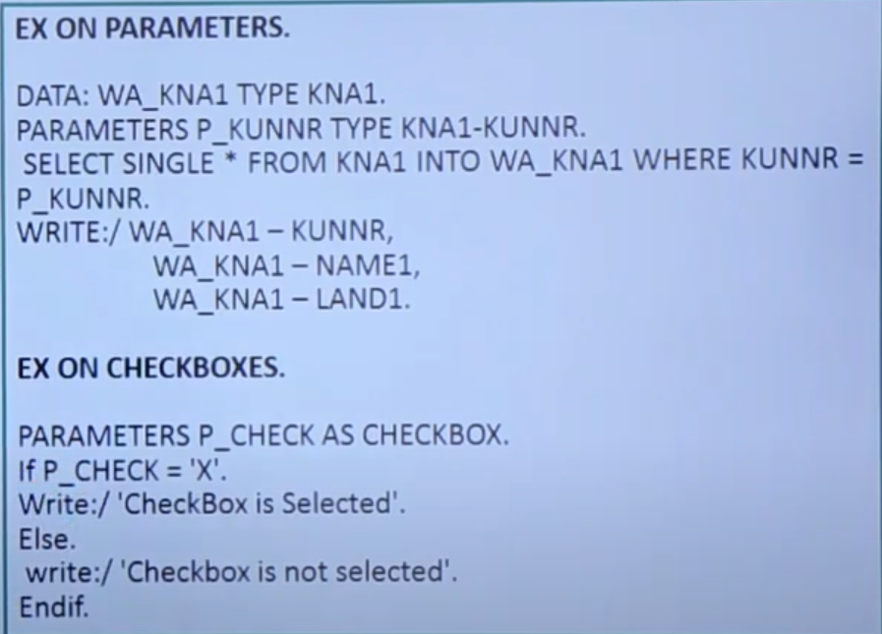

1. **SELECT OPTION:**

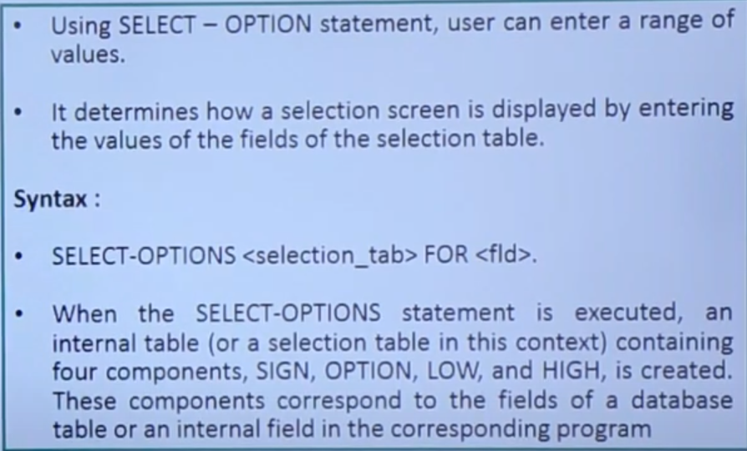

**Example:**

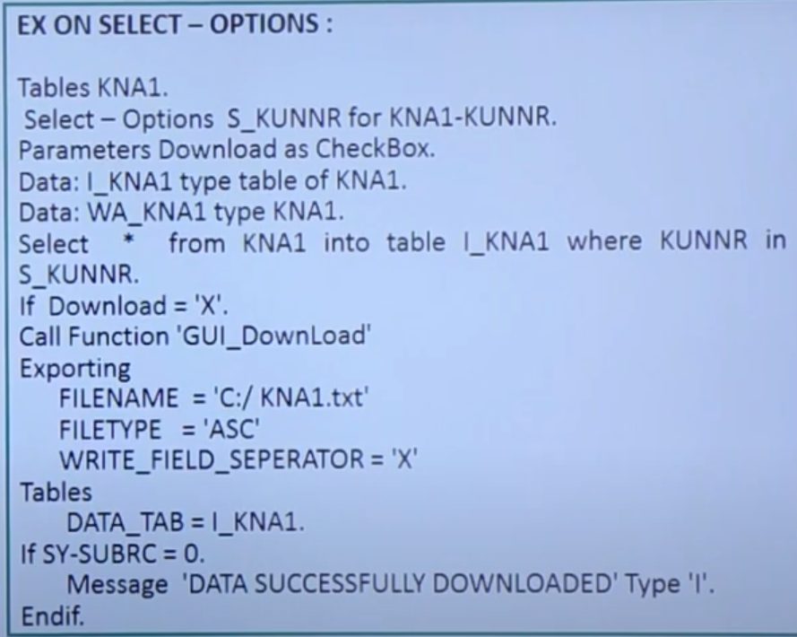

1. **SELECTION SCREEN STATEMENT:**

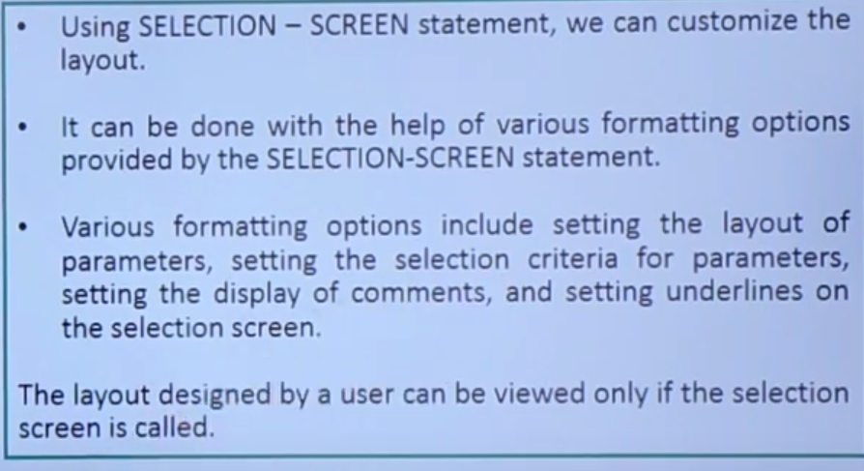

**MODULARIZATION:**

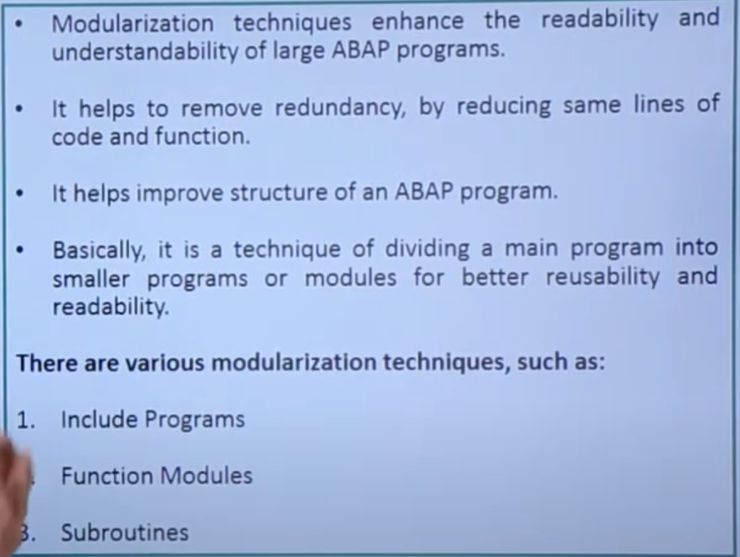

1. **INCLUDE PROGRAMS:**

* Include programs are global repository objects used to modularize the source code.
* They allows you to use the same source code in different programs.
* They also allows you to manage complex programs in an orderly way.
* To use an include program in another program, use the following syntax of include statement. i. e; INCLUDE <INCL>

**The following restrictions must be considered while writing the source code for include programs.**

* Include programs cannot call themselves.
* Include programs must contain complete statements.
* **SE38 is the T- code to open ABAP Editor.**

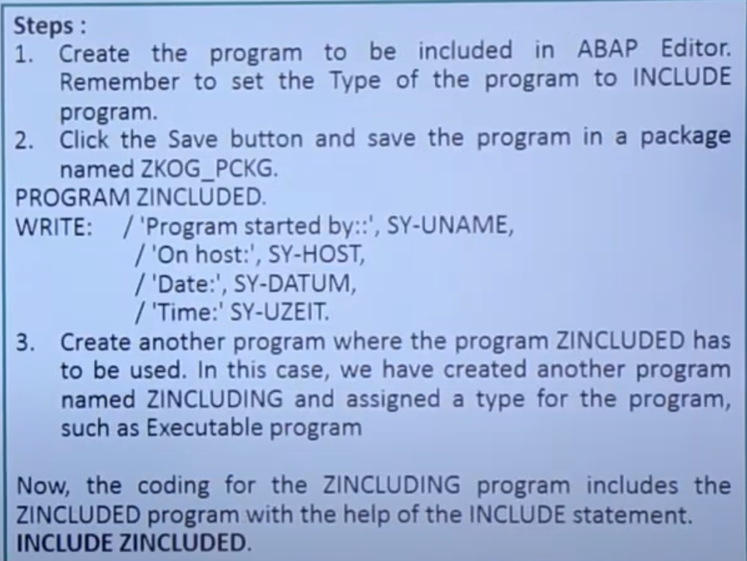

1. **FUNCTION MODULES:**

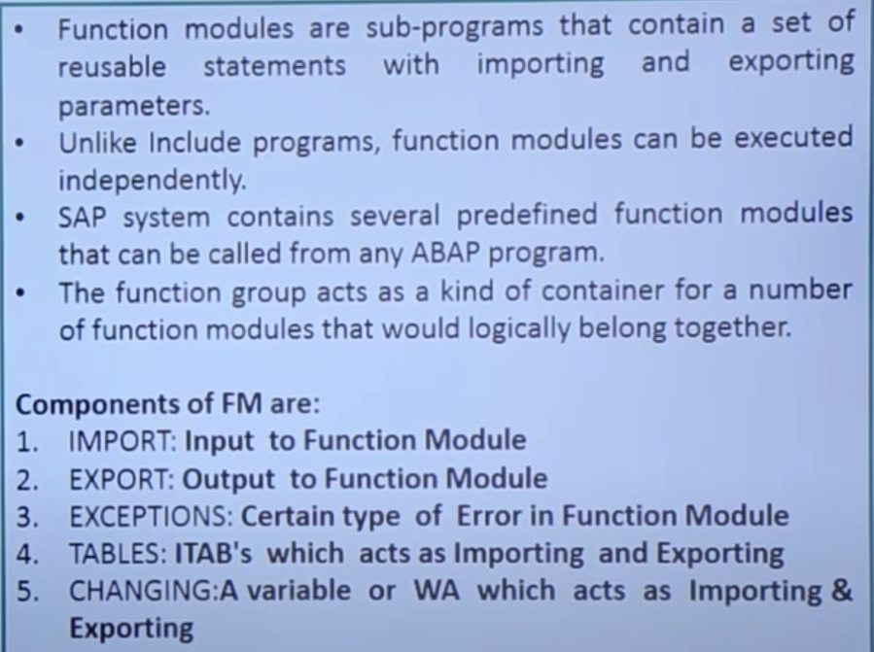

**STEPS TO CREATE A FUNCTION MODULE:**

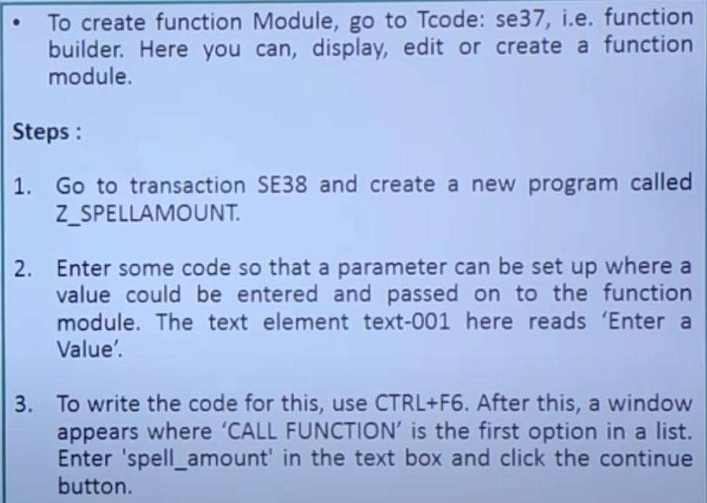

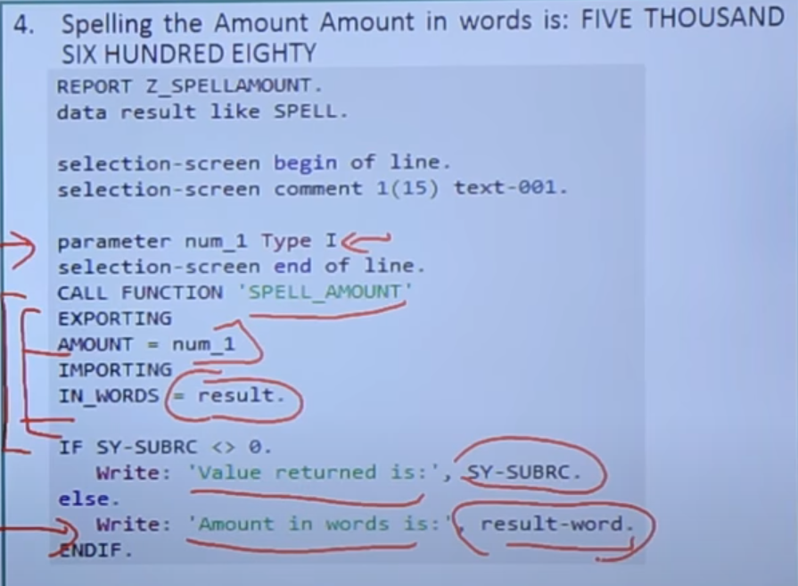

1. **SUBROUTINES:-**

* Subroutines are a mini program that consists of sequence of statements.
* It is used to prevent redundancy of the statements of ABAP Program.
* It starts with FORM, ends with ENDFORM and in-between can execute variables statements of ABAP Program.

There are two types of Subroutines.

1. Local Subroutines:-

Definition and implementation is in same program.

1. Global Subroutines:-

Definition is in one program and implementation is in another program.

Messages in ABAP:

* All the messages is stored in message class.
* A single message class is used for the entire Project.
* Message class is created used SE91 Transaction Code.
* Message ID is assigned to message class to our report.
* Our report can access all the messages in the message class.
* Syntax:- **MESSAGE<message> TYPE <MESSAGE TYPE>**

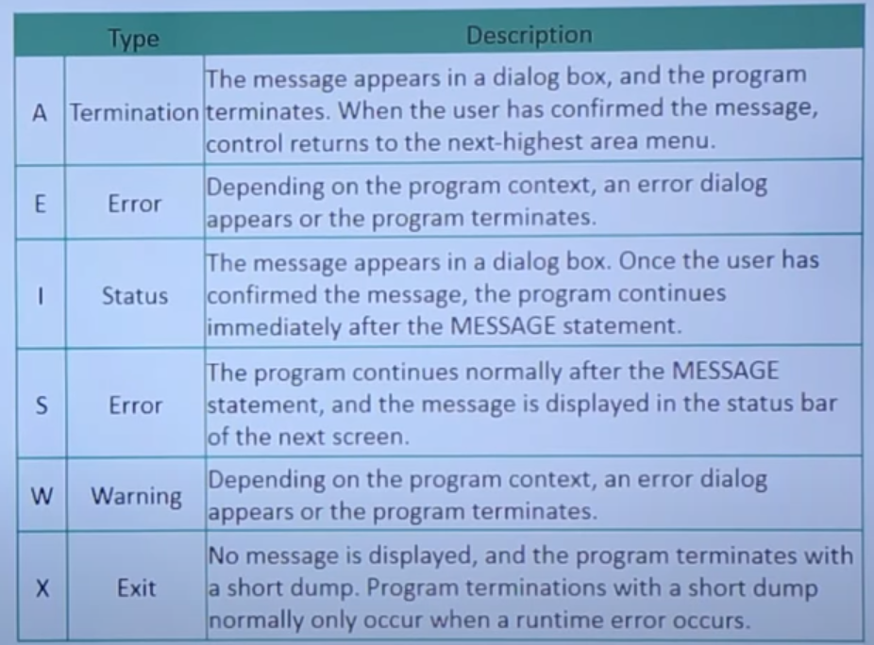

* Status: (S):

Syntax:- **MESSAGE** ‘message’ **TYPE ‘S’**

* Information: (I):

Syntax:- **MESSAGE** ‘This is an Information message’ **TYPE ‘I’**

* Error: (E):

Syntax:- **MESSAGE** ‘This is an Error message’ **TYPE ‘E’**

* Warning : (W): same as error message

Syntax:- **MESSAGE** ‘message’ **TYPE ‘W’**

* Exit: (X):

No message is displayed and the program terminates with the short dump.

Short dumps can be viewed in T-Code ST22

Syntax:- **MESSAGE** ‘This produces short dump’ **TYPE ‘X’**

* Termination: (A):

Syntax:- **MESSAGE** ‘Termination message’ **TYPE ‘A’**

Creating a message:

Menu GOTO >>> TEST Elements >>> Test Symbols.

REPORTS IN ABAP:

A report is a presentation of data in a specified format and organized structure.

Types of Reports:

1. **Classical Report:**

* The output is displayed in a single list.
* It is created using the output data, in WRITE statement inside a loop.
* We can use various events such as INITIALIS ATION, TOP-OF-PAGE to create a classical report.

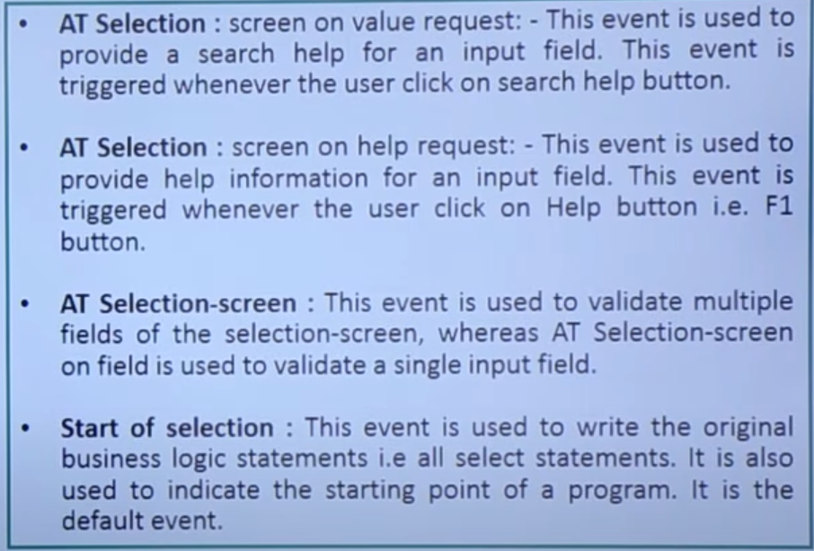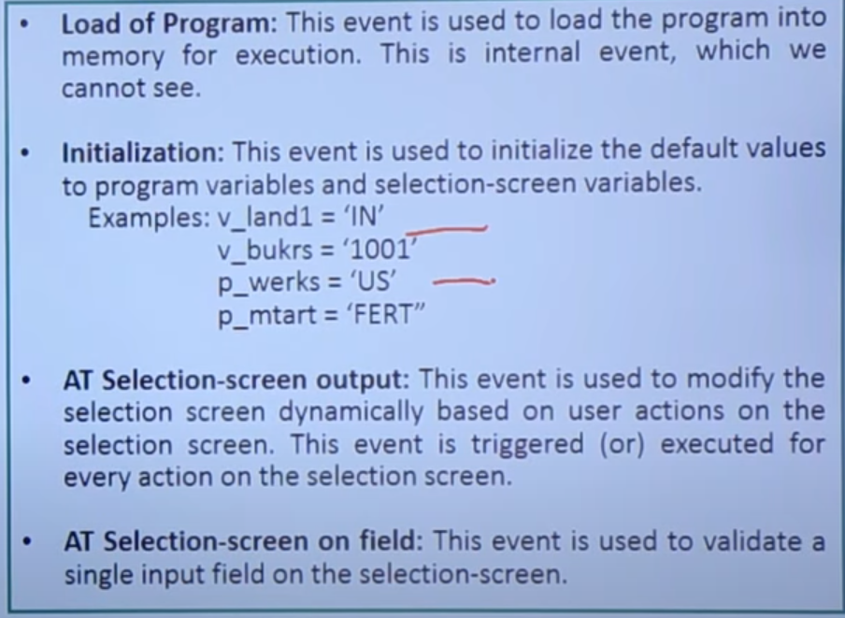

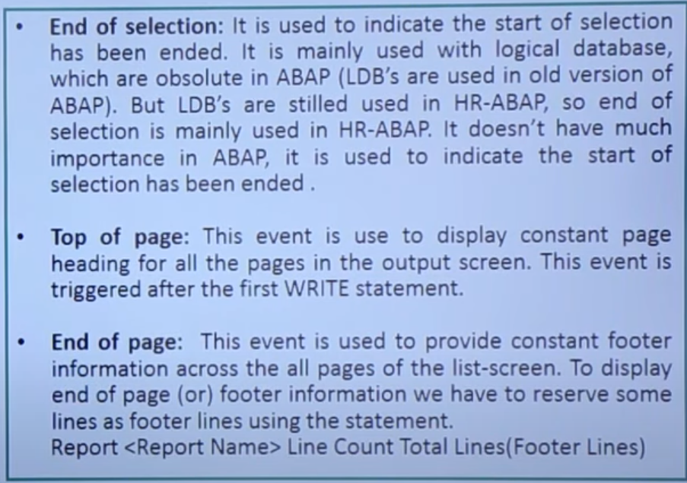

1. **Interactive Report**:

* It allows you to control the retrieval of data.
* It can view multiple lists simultaneously, firstly it displays basic list which starts with number ‘0’.
* The other lists are secondary lists which provide detailed description of data which starts from ‘1 to 20’.
* The list numbers are stored in system variable SY-LSIND
* And if you select any line, selected line data is stored in SY-LISEL.

1. **ABAP List Viewer (ALV) Reports**:

* It is a pre-defined report format in SAP.
* It allows you to perform various functions such as sorting, filtering, arranging and retrieving data.
* Can use various ALV Function Modules to perform functions on the data of report.
* Also can view the output of ALV in a list view or grid view by using **REUSE_ALV_LIST_DISPLAY** and **REUSE_ALV_GRID_DISPLAY** function modules respectively.

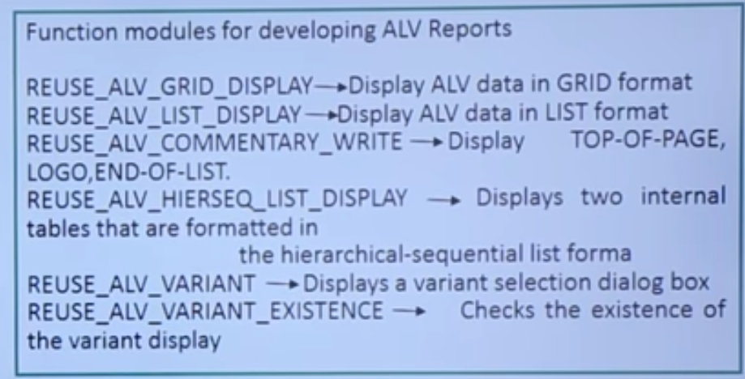

SAMPLE OF ALV REPORT: 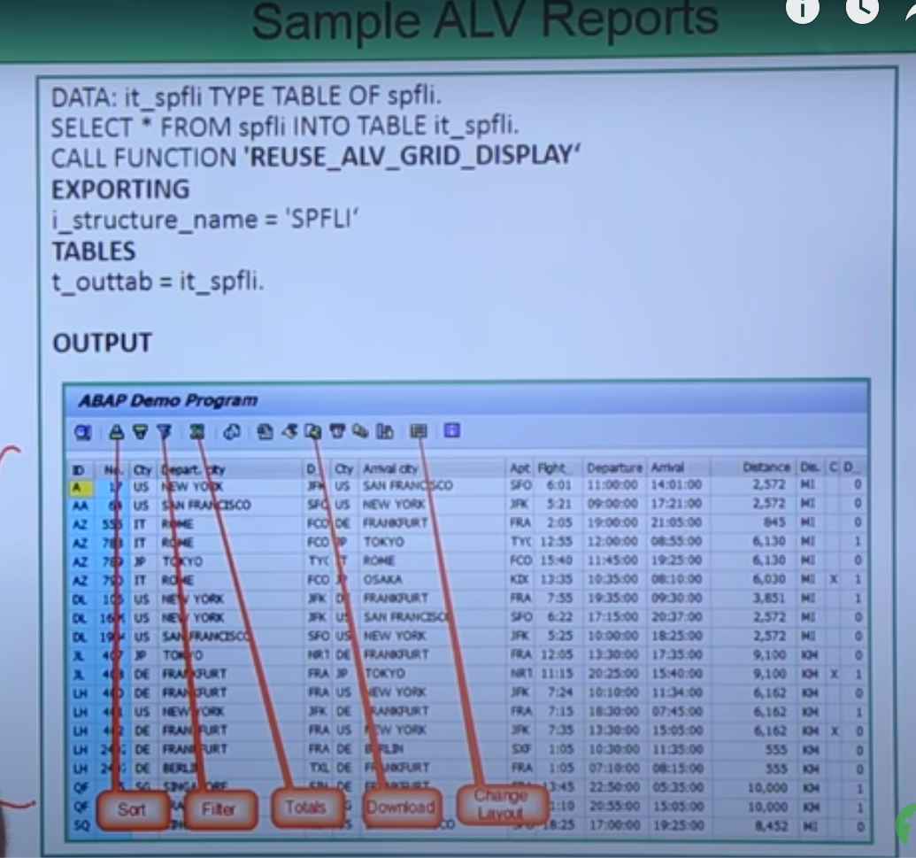

**BUSINESS APPLICATION PROGRAMMING INTERFACE (BAPI):**

* It is also a remote function module which is used to communicate between SAP-SAP or SAP-NONSAP servers.
* BAPI uses RFC technology, which is initially a RFC function module.
* BAPI’s are defined in a **BUSINESS OBJECT REPOSITORY**(**BOS**) as methods of SAP business object types that carry out specific business functions.

**BUSINESS OBJECT REPOSITORY:**

* It is a central access point for SAP business object types and their BAPI’s.
* It is developed for SAP business workflow.
* Today, we also used it for Archive link, output control and other generic object services.

**BUSINESS OBJECTS:**

* It is object which is similar to class, which is a group of attributes methods, interfaces, key fields, events for a particular business application or scenario.
* **SWO1** is T-Code forBusiness object repository.

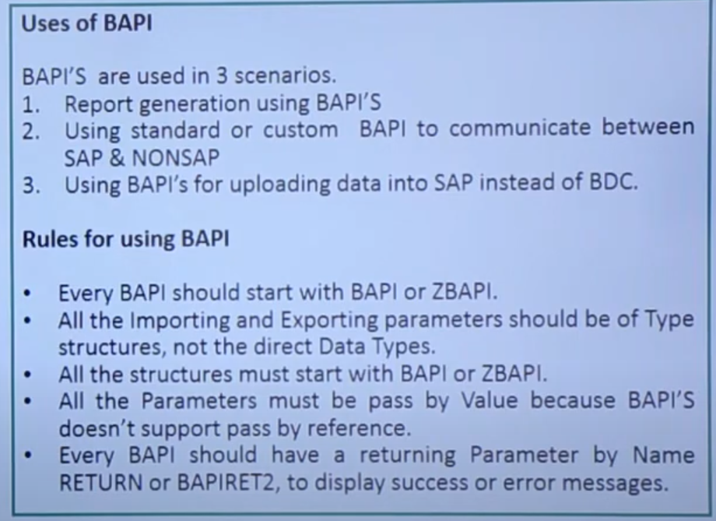

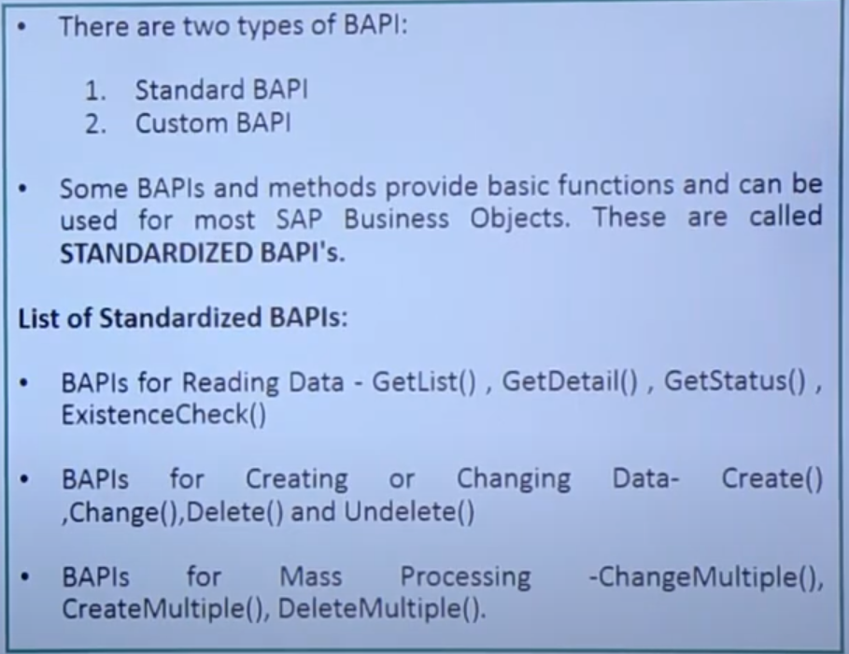

1. Standard BAPI: read above picture
2. Custom BAPI:

* Import / Export structure

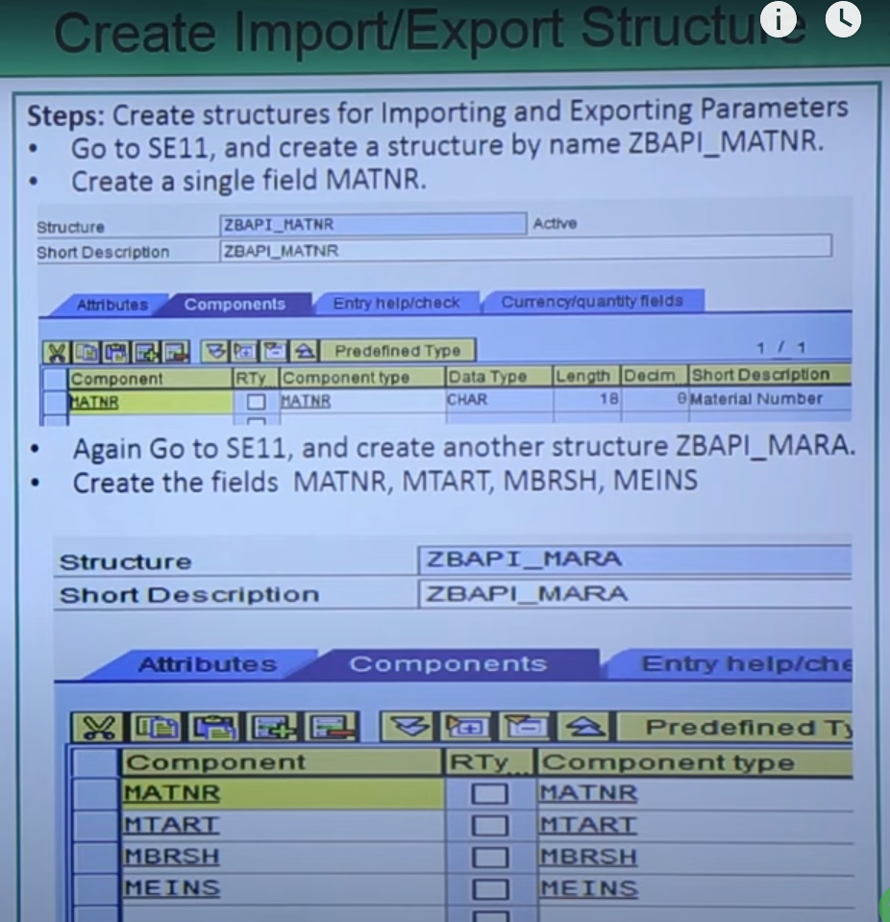

* Create a function module

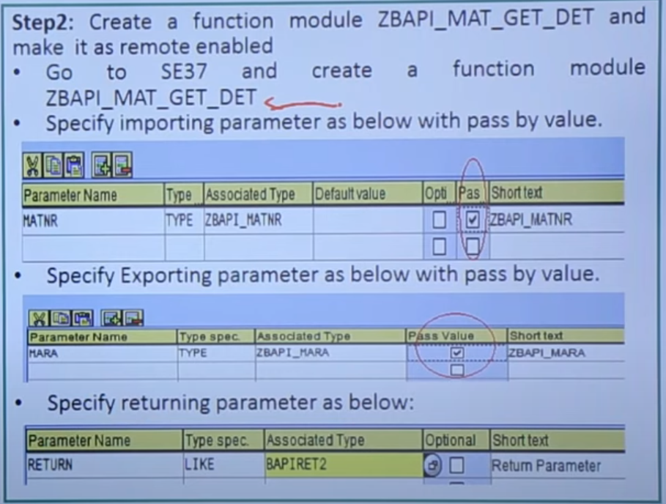

* Click on Source code and enter the code and remote enabled from ATTRIBUTES tab.

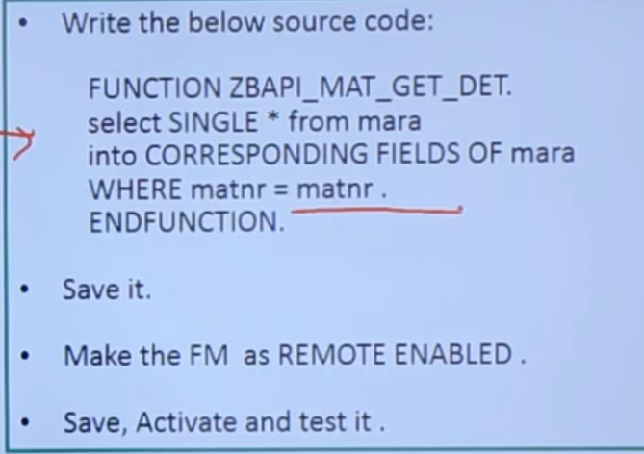

* Create a Business object:
  + - * 1. Go to **SWO1** T-code and name it
        2. Click Create and specify details and at last Application give it * cross.
        3. Then click the cursor on methods and click on Utilities from MENU

UTILITIES>>API-METHODS>>ADD METHOD

* + - * 1. Enter function module name and click on NEXT(>).
        2. Click again on Next and then click on Yes.
        3. Now our RFC is converted into BAPI
        4. Click on SAVE and click on BACK
* **Insert RFC into BO,** Goto OBJECT TYPEFROM MENU

**OBJECT TYPE >> CHANGE RELEASE STATUS TO >> IMPLEMENTED.**

**OBJECT TYPE >> CHANGE RELEASE STATUS TO >> RELEASED.**

**BATCH DATA COMMUNICATION (BDC):**

It is technique of transferring the data from legacy system (Non-SAP) to SAP.

It is two types.

Outbound process:

The process of transferring the data from SAP to Non-SAP or another SAP server.

Inbound process:

The process of receiving the data from Non-SAP server to SAP server.

**BDC Data:**

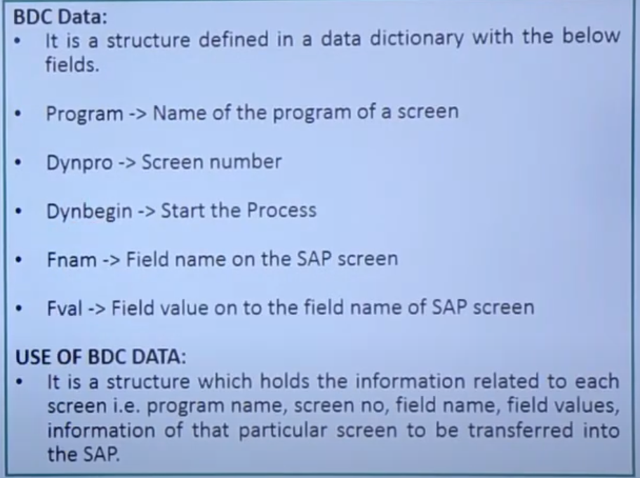

**Different methods of BDC**:

1. **Call transaction** 🡪(screen level processing):

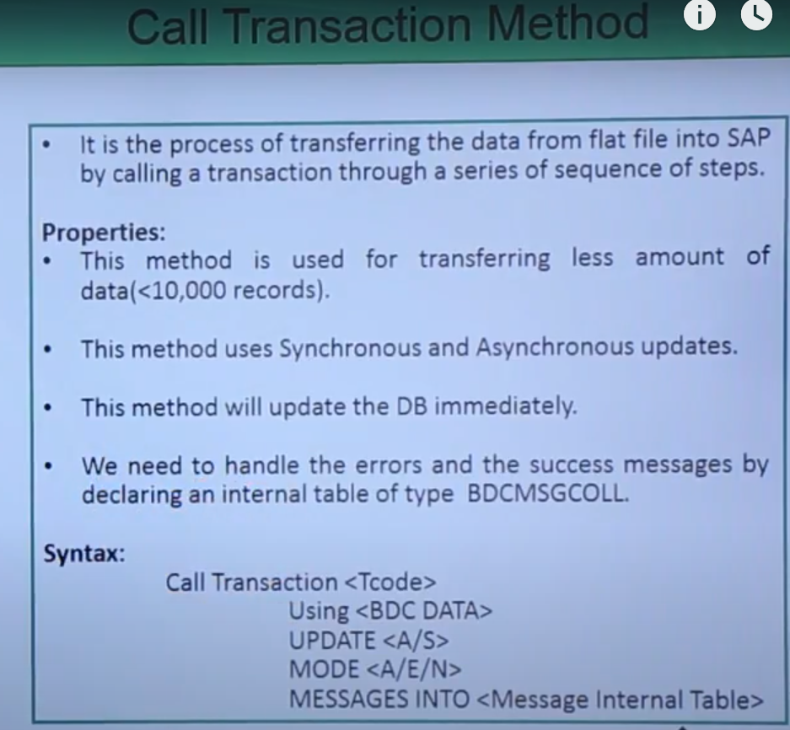

Update:

* Synchronous Update:

It will wait for the update to be finished, then it continues to process the next record.

* Asynchronous Update

It starts to process the next record without waiting the update to be finished.

Mode:

* A ----- All Screen mode
* E ----- Error Screen mode
* N No screen mode

MESSAGES:

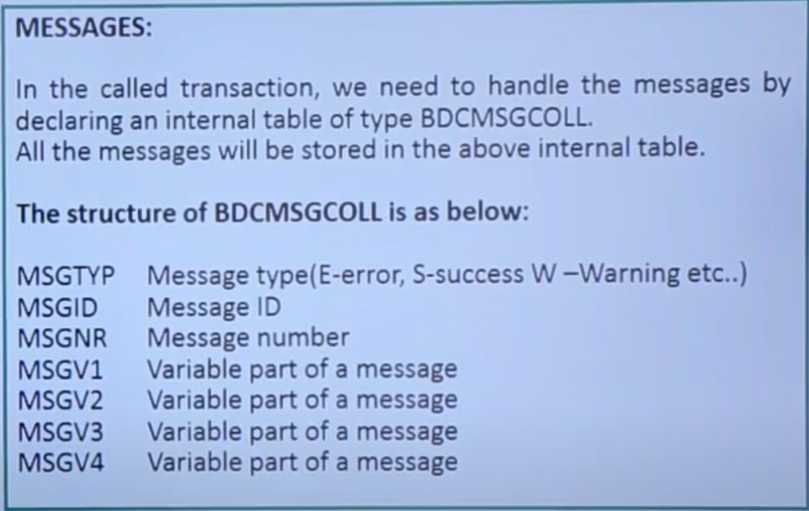

**RECORDING METHOD:**

It is very difficult to find technical information of each field on the screen, we go for method ‘Recording method’.

This recording methods records all the fields in the transaction and generates technical information such as program name, screen no, field name, field value for each field on SAP screen.

**Steps to recording a transaction:**

* T-code to record a transaction is **SHDB.**
* Go to **SHDB** and click on New recording.
* Enter the recording name and enter the Transaction code as **MMO1 to create recording** and click on start recording.
* MMO1 screen is displayed, then enter **Industry sector** and **Material type**.
* Then click on **Select Views** and select **Basic Data 1** and click on continue button.
* Then enter the **Description** and **basic unit of measure** as kg’s.
* Click on Save, then the recording will display all the technical information.
* Click on save and go back, then
* Select the recording and click on **program** to create a program and name it.
* **Select transfer from recording** and press enter
* Give the **title** and click on **source code**, then code will generate.
* Remove unwanted lines and continue first 4 steps written in below image.
* Create an internal table of flat file type structure.
* Upload the data from flat file into the internal table using call function GUI_upload.
* Give path to flat file and loop internal table to workArea.
* Copy the code generated from recording and paste it here.
* Perform BDC-Dynpro using <prog name > and <screen no>
* Perform BDC-Field using <fname> <fvalue>

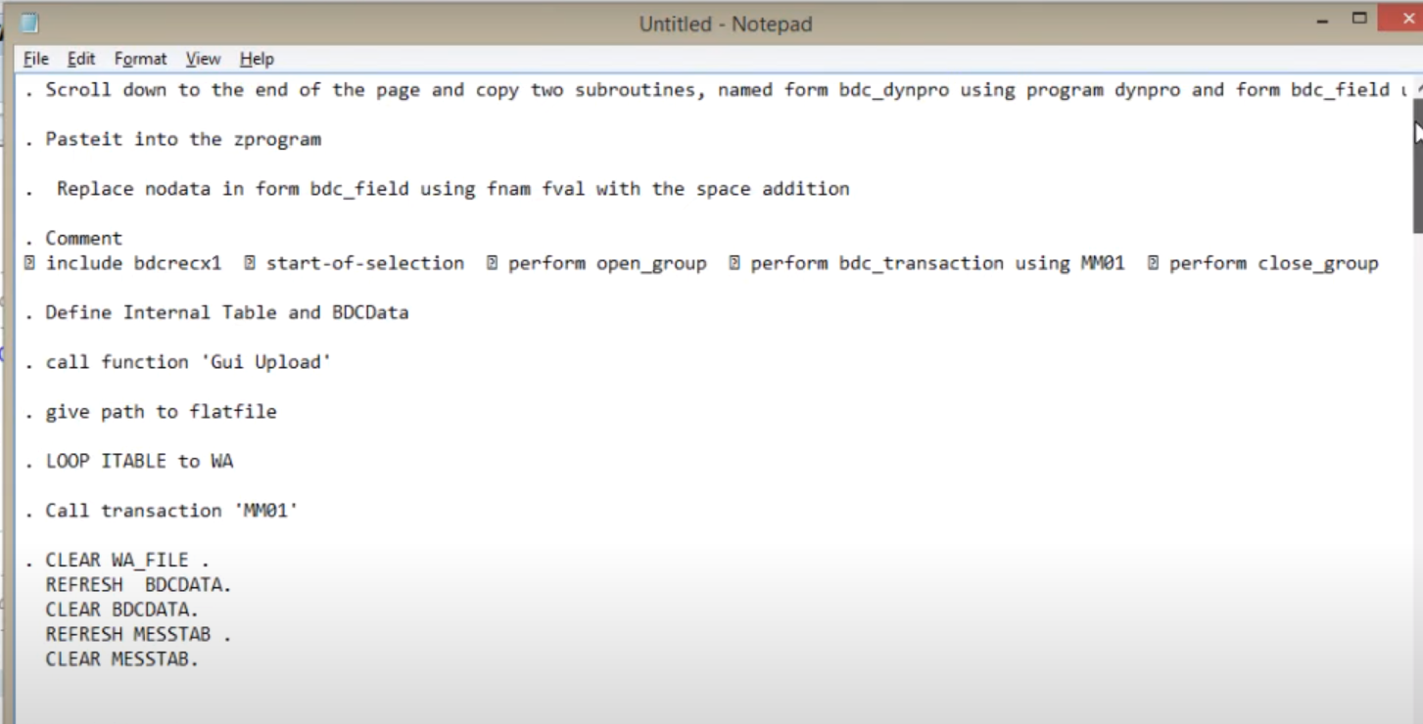

* Call transaction code ‘MMO1’ call transaction

Using BDC DATA

Update A/S

Mode A/E/N

Message into MESSTAB

* If SY-SUBRC=0.

Perform display_success_rec. (subroutine for success rec’s)

Else

Perform display_error_rec. (subroutine for error rec’s)

Endif.

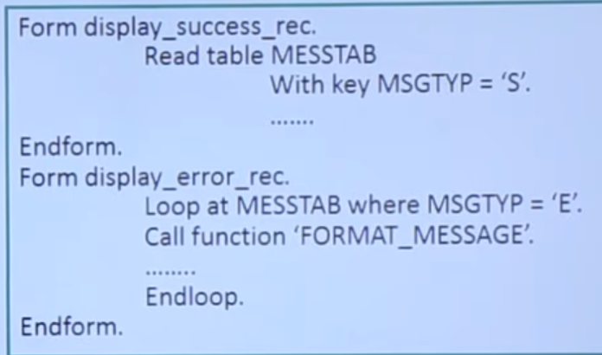

1. **Session method**🡪( screen level processing)

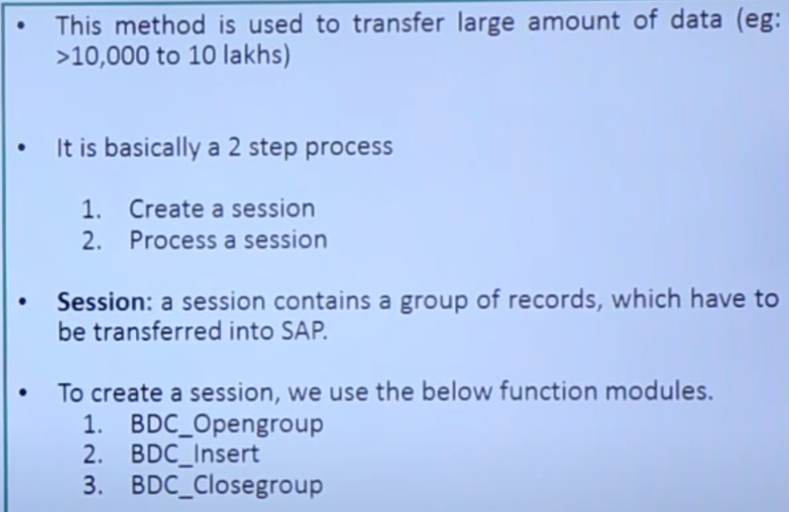

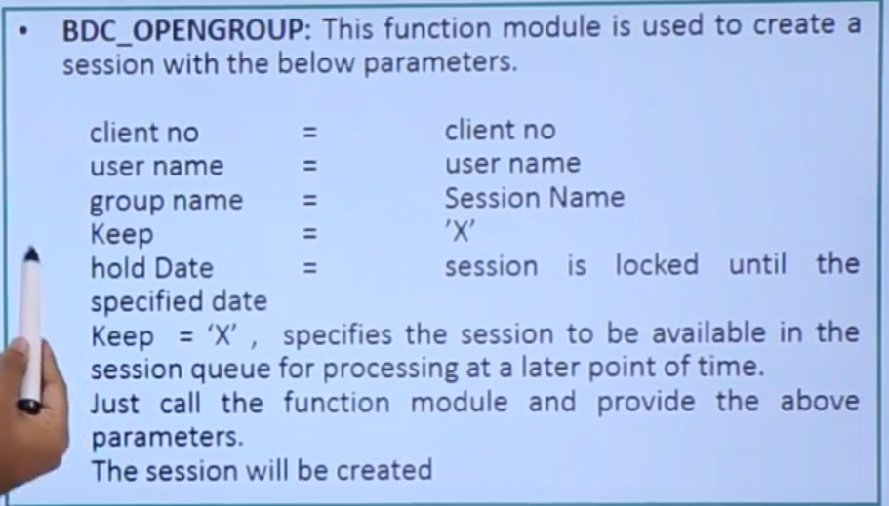

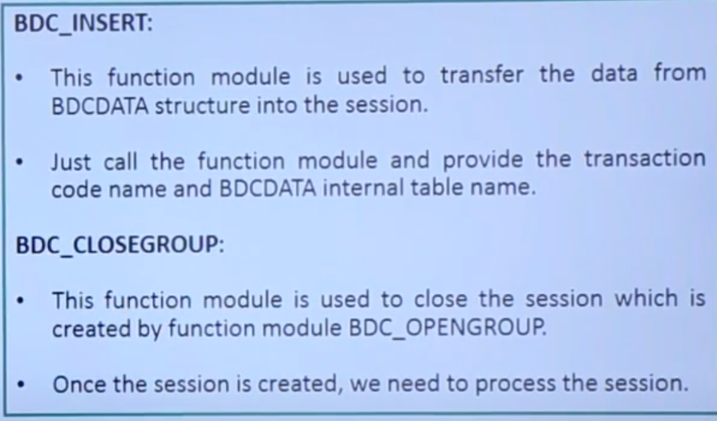

**SM35** is the T-code to **process the session**.

* Go to SM35 and select the session name
* Click on process button
* Select foreground or background or error mode , click on process
* The session is processed

**Status of session**

* Select the session name
* Click on button analysis
* Click on tap log

1. **Direct input method**🡪(Standard SAP program)

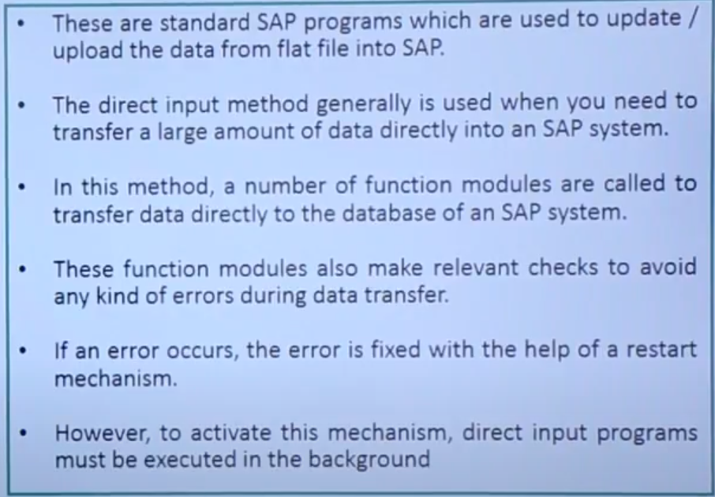

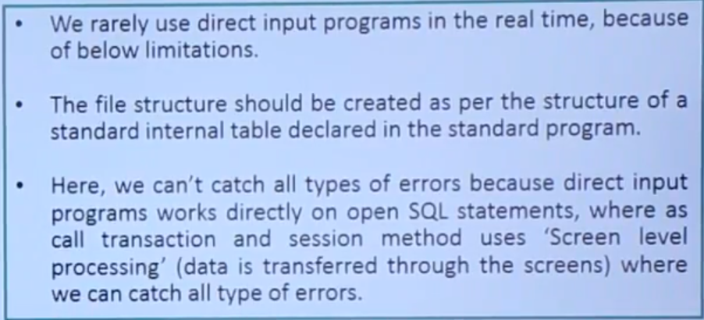

1. **LSMW** 🡪(A tool)

**LEGACY SYSTEM MIGRATION WORKBENCH**

